**PROJECT ON:**

AUCTIONS TABLE

**DEVELOP BY:**

|  |  |
| --- | --- |
| NAME | STUDENT ID: |
| EUNICE WILLIAMS MOLAKE | Student1309534 |
| ISSAH ABDUL SAMED | Student1304937 |

**STARTING DATE:**

8TH SEPTEMBER, 2021

**END DATE**:

7TH OCTOBER, 2021

NAME OF CORDINATOR: MARK BANSAH

|  |
| --- |
| CERTIFICATE |

This is to certify that this report titled “AUCTIONS TABLE” contains the original work done by the Group which includes: (**EUNICE WILLIAMS MOLAKE AND ISSAH ABDUL SAMED**) in fulfillment of course studied at Aptech Computer Education in the Software Dept.

|  |
| --- |
| **ACKNOWLEDGEMENT** |

We give sincere gratitude to God Almighty for granting us the strength and grace to be able to complete this project successfully.

We thank our course Instructor MARK BANSAH for his patience, encouragement and fervent tuition.

We also thank the Centre head for his relentless coordination and hard work.

Last but not the least, we thank the owner of Aptech-Ghana Mr. Emmanuel Twum-Obeng for introducing Aptech Computer Education in Ghana, giving us the privilege to pursue Aptech worldwide course here in Ghana.

AUCTIONS TABLE

AuctionsTable is an organization selling valuable items and goods through auctions. They have a vast experience of organizing auctions for past 25 years.

MOTIVE BEHIND AUCTIONS TABLE WEBSITE

**AuctionsTable** was created for the following reasons;

1. **Bid for preferred item at your comfort:** With a website providing all items at your fingertips, you can sit at home, workplace or anywhere and buy your preferred item by placing bids to win and purchase.
2. **Explore wide range of products**: With the provided website, clients will be able to view all items available even if it is not at their interest but the pictures provided may cause you to like the item and purchase.
3. **Easy management and finalizing auctions**: Management of AuctionsTable will be able to see and confirm winner of an item across the world and delivering it to client after payment.

Concept of AuctionsTable

HOME PAGE

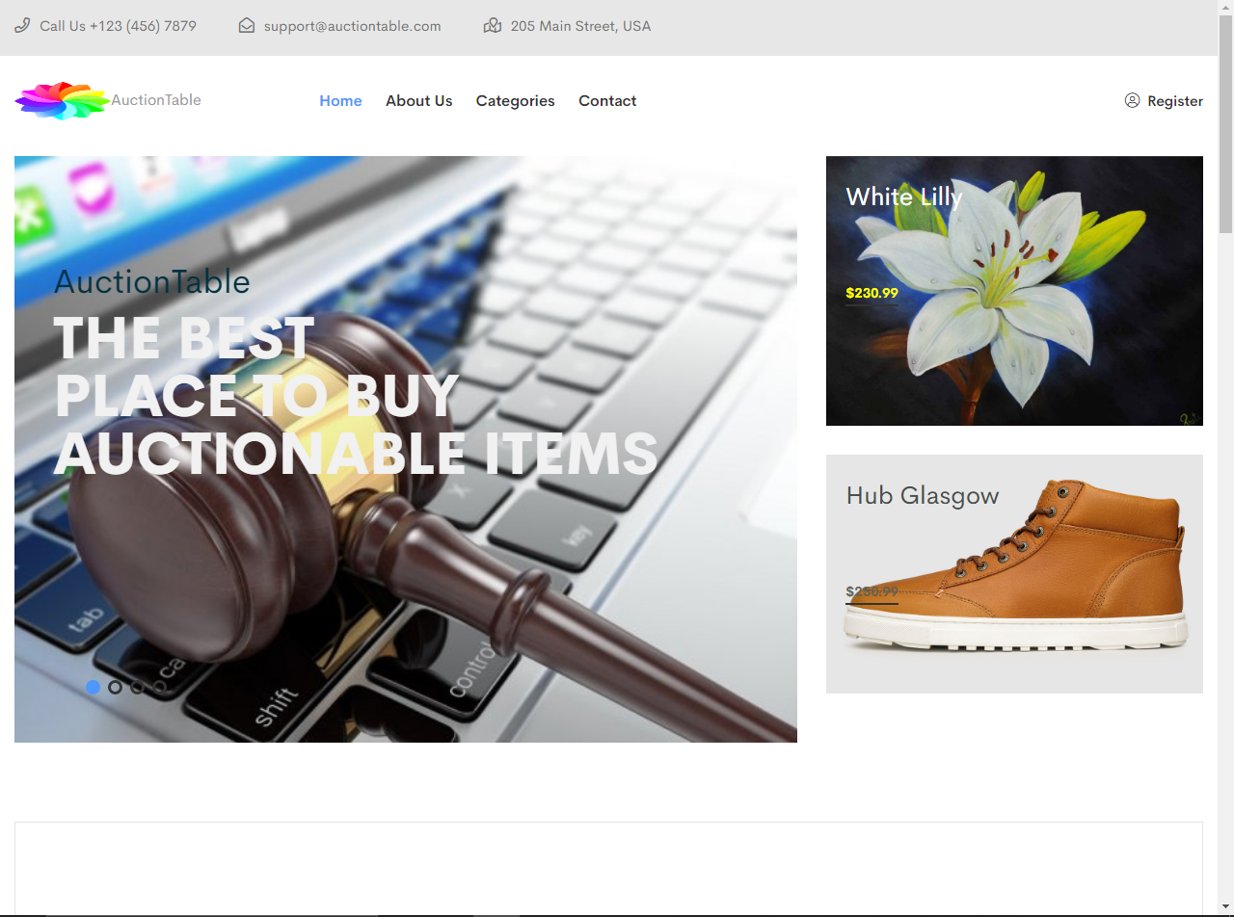

SOURCE CODES

<!-- header-start -->

        <header>

            <div class="header-area grey-3-bg pl-55 pr-55">

                <div class="container-fluid">

                    <div class="row">

                        <div class="col-xl-8 col-lg-9 col-md-8">

                            <div class="header-top-wrapper">

                                <div class="header-info">

                                    <span><i class="far fa-phone"></i> Call Us +123 (456) 7879</span>

                                    <span class="envelopes-header-icon"><i class="far fa-envelope-open"></i> support@auctiontable.com</span>

                                    <span class="mails-header-icon"><i class="far fa-map-marked"></i> 205 Main Street, USA</span>

                                </div>

                            </div>

                        </div>

                    </div>

                </div>

            </div>

            <div id="sticky-header" class="main-menu-area menu-02 pl-55 pr-55">

                <div class="container-fluid">

                    <div class="row align-items-center">

                        <div class="col-xl-3 col-lg-3 col-md-3">

                            <div class="logo">

                                <a href="index.html"><img src="assets/img/logo/logo.png" alt="" style="width: 100px;height: 40px;" />AuctionTable</a>

                            </div>

                        </div>

                        <div class="col-xl-5 col-lg-6">

                            <div class="main-menu">

                                <nav id="mobile-menu">

                                    <ul>

                                        <li class="active"><a href="index.html">home</a></li>

                                        <li><a href="about.html">About Us </a></li>

                                        <li><a>Categories</a>

                                            <ul class="sub-menu text-left">

                                                <li><a href="furniture.html">Furniture</a>

                                                <li><a href="paintings.html">Paintings</a>

                                                <li><a href="automobile.html">Automobile</a>

                                                <li><a href="electronics.html">Electronics</a>

                                                <li><a href="fashion.html">Fashion</a>

                                                <li><a href="health.html">Health</a>

                                                <li><a href="accessories.html">Accessories</a>

                                            </ul>

                                        </li>

                                        <li><a href="contact.html">contact</a></li>

                                    </ul>

                                </nav>

                            </div>

                        </div>

                        <div class="col-xl-4 col-lg-3">

                            <div class="header-top-right text-md-right d-none d-lg-block">

                                <div class="shop-menu">

                                    <ul>

                                        <li><a class="my-icon" href="register.html"><i class="fal fa-user-circle"></i> Register</a></li>

                                    </ul>

                                </div>

                            </div>

                        </div>

                        <div class="col-12">

                            <div class="mobile-menu"></div>

                        </div>

                    </div>

                </div>

            </div>

            <div class="extra-info">

                <div class="close-icon">

                    <button>

                        <i class="far fa-window-close"></i>

                    </button>

                </div>

                <div class="logo-side mb-30">

                    <a href="index.html">

                        <img src="assets/img/logo/white-logo.png" alt="" />

                    </a>

                </div>

                <div class="side-info mb-30">

                    <div class="contact-list mb-30">

                        <h4>Office Address</h4>

                        <p>123/A, Miranda City Likaoli

                            Prikano, Dope</p>

                    </div>

                    <div class="contact-list mb-30">

                        <h4>Phone Number</h4>

                        <p>+0989 7876 9865 9</p>

                        <p>+(090) 8765 86543 85</p>

                    </div>

                    <div class="contact-list mb-30">

                        <h4>Email Address</h4>

                        <p>info@example.com</p>

                        <p>example.mail@hum.com</p>

                    </div>

                </div>

            </div>

        </header>

        <!-- header-start -->

        <main>

            <!-- banner-area-start -->

            <div class="banner-area banner-pb pt-10 pb-30 pl-55 pr-55">

                <div class="container-fluid">

                    <div class="row">

                        <div class="col-xl-8 col-lg-8 col-md-12">

                            <div class="banners-active">

                                <div class="banners-wrapper mb-30">

                                    <div class="banner-img pos-rel">

                                        <a><img src="assets/img/banner/laptop.jpg" alt=""></a>

                                        <div class="banner-content">

                                            <span>AuctionTable</span>

                                            <h2 style="color: #f1f1f1;">The Best <br>Place To Buy <br>Auctionable Items</h2>

                                        </div>

                                    </div>

                                </div>

                                <div class="banners-wrapper mb-30">

                                    <div class="banner-img pos-rel">

                                        <a href="face.html"><img src="assets/img/paintings/face 1.jpg" alt=""></a>

                                        <div class="banner-content">

                                            <span>Paintings</span>

                                            <h2 style="color: #f1f1f1;">Makeup nice <br>wall hangings</h2>

                                            <div class="bannerss-button">

                                                <a class="c-btn" href="face.html">bid now <i class="far fa-plus"></i></a>

                                            </div>

                                        </div>

                                    </div>

                                </div>

                                    <div class="banners-wrapper mb-30">

                                    <div class="banner-img pos-rel">

                                        <a href="hyundai.html"><img src="assets/img/cars/hyundai_veloster3.jpg" alt=""></a>

                                        <div class="banner-content">

                                            <span>Automobile</span>

                                            <h2 style="color: #d9dfe0;">Drive smooth<br>with Hyundai <br> veloster</h2>

                                            <div class="bannerss-button">

                                                <a class="c-btn" href="hyundai.html">bid now <i class="far fa-plus"></i></a>

                                            </div>

                                        </div>

                                    </div>

                                </div>

                                    <div class="banners-wrapper mb-30">

                                    <div class="banner-img pos-rel">

                                        <a><img src="assets/img/banner/people-gb9aff7911_1920.jpg" alt=""></a>

                                        <div class="banner-content">

                                            <span>AuctionTable</span>

                                            <h2 style="color: #f1f1f1;">The Best <br>Place To Buy And <br>Sell</h2>

                                        </div>

                                    </div>

                                </div>

                            </div>

                        </div>

                        <div class="col-xl-4 col-lg-4 col-md-12">

                            <div class="banner-wrapper mb-30">

                                <div class="banner-img pos-rel">

                                    <a href="white-flower.html">

                                    <img src="assets/img/paintings/white flower 1.jpg" alt="">

                                    <div class="banner-text banner-03-text">

                                        <span style="color: white;">White Lilly</span>

                                        <br><br><br><br>

                                        <div class="b-button ">

                                            <a href="white-flower.html" style="color: yellow;">$230.99 </a>

                                         </div>

                                    </div>

                                    </a>

                                </div>

                            </div>

                            <div class="banner-wrapper mb-30">

                                <div class="banner-img pos-rel">

                                    <a href="hub.html"><img src="assets/img/fashion/hub_h_glasgow_1.jpg" alt="">

                                    <div class="banner-text banner-03-text">

                                        <span style="color: rgb(72, 78, 75);" class="pull-right">Hub Glasgow</span>

                                        <br><br><br><br>

                                        <div class="b-button">

                                            <a href="hub.html" style="color: rgb(100, 100, 83);">$250.99 </a>

                                         </div>

                                    </div>

                                    </a>

                                </div>

                            </div>

                        </div>

                    </div>

                </div>

            </div>

            <!-- banner-area-end -->

|  |
| --- |
|  |
|  |  |
|  |  |
|  |  |
|  |  |
|  |  |
|  |  |
|  |  |
|  |  |
|  |  |
|  |  |
|  |  |
|  |  |
|  |  |
|  |  |

FEATURED AUCTIONS

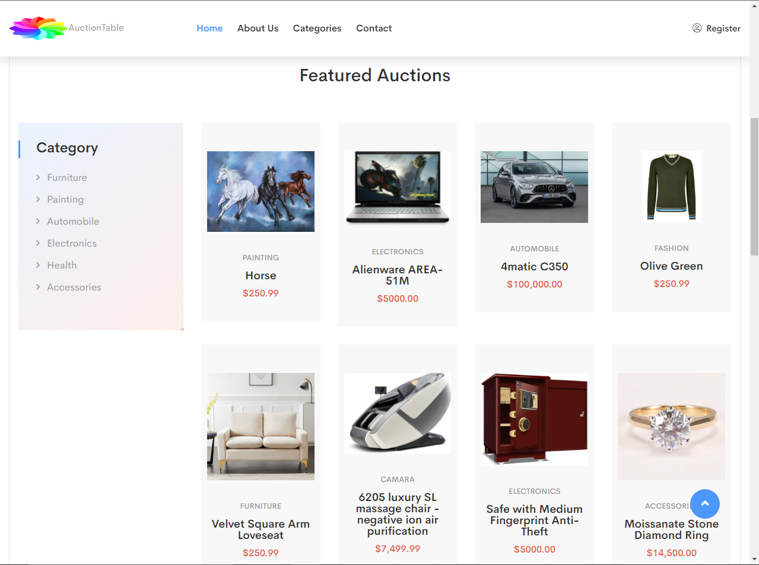

SOURCE CODES

**<!-- featured-products-area-start -->**

**<div class="features-products-area fe-product pl-55 pr-55">**

**<div class="container-fluid">**

**<div class="fe-pro-border">**

**<div class="row">**

**<div class="col-xl-6 col-lg-6 offset-lg-3 offset-xl-3">**

**<div class="section-title text-center mb-65">**

**<h2>Featured Auctions</h2>**

**</div>**

**</div>**

**</div>**

**<div class="row">**

**<div class="col-xl-3 col-lg-3 mb-30">**

**<div class="category-sidebar">**

**<h3 class="cat-title">Category</h3>**

**<div class="category-item">**

**<ul>**

**<li><a href="furniture 1.html">Furniture</a></li>**

**<li><a href="paintings.html">Painting</a></li>**

**<li><a href="automobile.html">Automobile</a></li>**

**<li><a href="electronics.html">Electronics</a></li>**

**<li><a href="health.html">Health</a></li>**

**<li><a href="accessories.html">Accessories</a></li>**

**</ul>**

**</div>**

**</div>**

**</div>**

**<div class="col-xl-9 col-lg-9">**

**<div class="row">**

**<div class="col-xl-3 cl-lg-3 col-md-6">**

**<div class="product-03-wrapper grey-2-bg pos-rel text-center mb-30">**

**<div class="product-02-img pos-rel">**

**<a href="horse.html">**

**<img src="assets/img/paintings/horse 1.jpg" alt="">**

**</a>**

**</div>**

**<div class="product-text">**

**<h5>painting</h5>**

**<h4><a href="horse.html">Horse</a></h4>**

**<span>$250.99</span>**

**</div>**

**</div>**

**</div>**

**<div class="col-xl-3 cl-lg-3 col-md-6">**

**<div class="product-03-wrapper grey-2-bg pos-rel text-center mb-30">**

**<div class="product-02-img pos-rel">**

**<a href="laptop.html">**

**<img src="assets/img/electronics/laptop1.jpg" alt="">**

**</a>**

**</div>**

**<div class="product-text">**

**<h5>electronics</h5>**

**<h4><a href="laptop.html">Alienware AREA-51M</a></h4>**

**<span>$5000.00</span>**

**</div>**

**</div>**

**</div>**

**<div class="col-xl-3 cl-lg-3 col-md-6">**

**<div class="product-03-wrapper grey-2-bg pos-rel text-center mb-30">**

**<div class="product-02-img pos-rel">**

**<a href="benz_4matic.html">**

**<img src="assets/img/cars/benz1.jpg" alt="">**

**</a>**

**</div>**

**<div class="product-text">**

**<h5>automobile</h5>**

**<h4><a href="benz_4matic.html">4matic C350</a></h4>**

**<span>$100,000.00</span>**

**</div>**

**</div>**

**</div>**

**<div class="col-xl-3 cl-lg-3 col-md-6">**

**<div class="product-03-wrapper grey-2-bg pos-rel text-center mb-30">**

**<div class="product-02-img pos-rel">**

**<a href="olive.html">**

**<img src="assets/img/fashion/olive green 1.jpg" style="height: 120px;" alt="">**

**</a>**

**</div>**

**<div class="product-text">**

**<h5>fashion</h5>**

**<h4><a href="olive.html">Olive Green</a></h4>**

**<span>$250.99</span>**

**</div>**

**</div>**

**</div>**

**<div class="col-xl-3 cl-lg-3 col-md-6">**

**<div class="product-03-wrapper grey-2-bg pos-rel text-center mb-30">**

**<div class="product-02-img pos-rel">**

**<a href="product_details.html">**

**<img src="assets/img/fashion/Velvet+Square+Arm+Loveseat 1.jpg" alt="">**

**</a>**

**</div>**

**<div class="product-text">**

**<h5>Furniture</h5>**

**<h4><a href="product_details.html">Velvet Square Arm Loveseat</a></h4>**

**<span>$250.99</span>**

**</div>**

**</div>**

**</div>**

**<div class="col-xl-3 cl-lg-3 col-md-6">**

**<div class="product-03-wrapper grey-2-bg pos-rel text-center mb-30">**

**<div class="product-02-img pos-rel">**

**<a href="massage.html">**

**<img src="assets/img/healthy/massage 1.jpg" alt="">**

**</a>**

**</div>**

**<div class="product-text">**

**<h5>camara</h5>**

**<h4><a href="massage.html">6205 luxury SL massage chair - negative ion air purification</a></h4>**

**<span>$7,499.99</span>**

**</div>**

**</div>**

**</div>**

**<div class="col-xl-3 cl-lg-3 col-md-6">**

**<div class="product-03-wrapper grey-2-bg pos-rel text-center mb-30">**

**<div class="product-02-img pos-rel">**

**<a href="safe.html">**

**<img src="assets/img/electronics/safe1.jpg" alt="">**

**</a>**

**</div>**

**<div class="product-text">**

**<h5>Electronics</h5>**

**<h4><a href="safe.html">Safe with Medium Fingerprint Anti-Theft</a></h4>**

**<span>$5000.00</span>**

**</div>**

**</div>**

**</div>**

**<div class="col-xl-3 cl-lg-3 col-md-6">**

**<div class="product-03-wrapper grey-2-bg pos-rel text-center mb-30">**

**<div class="product-02-img pos-rel">**

**<a href="d_ring.html">**

**<img src="assets/img/accessories/ring1.jpg" alt="">**

**</a>**

**</div>**

**<div class="product-text">**

**<h5>accessories</h5>**

**<h4><a href="d_ring.html">Moissanate Stone Diamond Ring</a></h4>**

**<span>$14,500.00</span>**

**</div>**

**</div>**

**</div>**

**</div>**

**</div>**

**</div>**

**</div>**

**</div>**

**</div>**

**<!-- featured-products-area-end -->**

**FINISHED AUCTIONS**

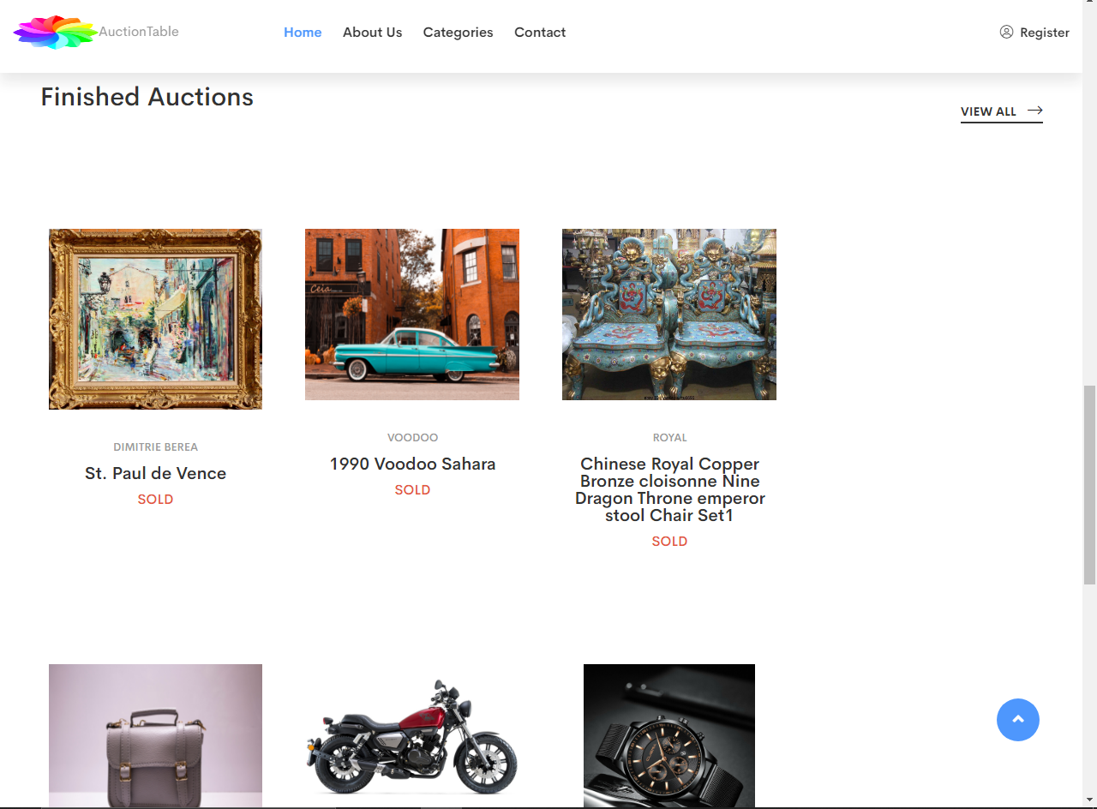

**SOURCE CODE**

**<!-- FINISHED-AUCTIONS-start -->**

**<div class="product-area pt-100 pb-70">**

**<div class="container">**

**<div class="row mb-30">**

**<div class="col-xl-7 col-lg-7 col-md-8">**

**<div class="section-title mb-30">**

**<h2>Finished Auctions</h2>**

**</div>**

**</div>**

**<div class="col-xl-5 col-lg-5 col-md-4">**

**<div class="b-button shop-btn s-btn text-md-right mb-30">**

**<a href="f_auctions.html">view all <i class="fal fa-long-arrow-right"></i></a>**

**</div>**

**</div>**

**</div>**

**<div class="row">**

**<div class="col-xl-9 col-lg-9">**

**<div class="row">**

**<div class="col-xl-4 cl-lg-4 col-md-6">**

**<div class="product-02-wrapper product-single pos-rel text-center mb-30">**

**<div class="product-02-img pos-rel">**

**<p>**

**<img src="assets/img/products/paint2.jpg" alt="">**

**</p>**

**</div>**

**<div class="product-text">**

**<h5>Dimitrie Berea</h5>**

**<h4><a>St. Paul de Vence</a></h4>**

**<span>SOLD</span>**

**</div>**

**</div>**

**</div>**

**<div class="col-xl-4 cl-lg-4 col-md-6">**

**<div class="product-02-wrapper product-single pos-rel text-center mb-30">**

**<div class="product-02-img pos-rel">**

**<p>**

**<img src="assets/img/cars/classic_car1.jpg" class="pop" alt="">**

**</p>**

**</div>**

**<div class="product-text">**

**<h5>Voodoo</h5>**

**<h4><a>1990 Voodoo Sahara</a></h4>**

**<span>SOLD</span>**

**</div>**

**</div>**

**</div>**

**<div class="col-xl-4 cl-lg-4 col-md-6">**

**<div class="product-02-wrapper product-single pos-rel text-center mb-30">**

**<div class="product-02-img pos-rel">**

**<p>**

**<img src="assets/img/products/royal_chair.jpg" class="pop" alt="">**

**</p>**

**</div>**

**<div class="product-text">**

**<h5>Royal</h5>**

**<h4><a>Chinese Royal Copper Bronze cloisonne Nine Dragon Throne emperor stool Chair Set1</a></h4>**

**<span>SOLD</span>**

**</div>**

**</div>**

**</div>**

**<div class="col-xl-4 cl-lg-4 col-md-6">**

**<div class="product-02-wrapper product-single pos-rel text-center mb-30">**

**<div class="product-02-img pos-rel">**

**<p>**

**<img src="assets/img/products/bag3.jpg" class="pop" alt="">**

**</p>**

**</div>**

**<div class="product-text">**

**<h5>Fashion</h5>**

**<h4><a>Louis Vuitton Bag</a></h4>**

**<span>SOLD</span>**

**</div>**

**</div>**

**</div>**

**<div class="col-xl-4 cl-lg-4 col-md-6">**

**<div class="product-02-wrapper product-single pos-rel text-center mb-30">**

**<div class="product-02-img pos-rel">**

**<p>**

**<img src="assets/img/products/freeway.jpg" alt="">**

**</p>**

**</div>**

**<div class="product-text">**

**<h5>KEEWAY</h5>**

**<h4><a>K-Light 125cc E5</a></h4>**

**<span>SOLD</span>**

**</div>**

**</div>**

**</div>**

**<div class="col-xl-4 cl-lg-4 col-md-6">**

**<div class="product-02-wrapper product-single pos-rel text-center mb-30">**

**<div class="product-02-img pos-rel">**

**<p>**

**<img src="assets/img/products/watch.jpg" class="pop" alt="">**

**</p>**

**</div>**

**<div class="product-text">**

**<h5>cuena</h5>**

**<h4><a>Waterproof Men's Luminous Classic Watches</a></h4>**

**<span>SOLD</span>**

**</div>**

**</div>**

**</div>**

**</div>**

**</div>**

**<div class="col-xl-3 col-lg-3 mb-30">**

**<div class="banner-pro-img">**

**<p href=""><img src="assets/img/products/banner.jpg" alt=""></p>**

**</div>**

**</div>**

**</div>**

**</div>**

**</div>**

**<!-- FINSHED-AUCTIONS-end -->**

**<!-- footer-area-start -->**

**<footer>**

**<div class="footer-bottom-area pt-25 pb-25">**

**<div class="container">**

**<div class="row">**

**<div class="col-xl-6 col-lg-6 col-md-6">**

**<div class="copyright">**

**<p>Copyright <i class="far fa-copyright"></i> 2020 <a href="#">Auction Table</a>. All Rights Reserved</p>**

**</div>**

**</div>**

**</div>**

**</div>**

**</div>**

**</footer>**

**<!-- footer-area-end -->**

**<!-- JS here -->**

**<script src="assets/js/vendor/modernizr-3.5.0.min.js"></script>**

**<script src="assets/js/vendor/jquery-1.12.4.min.js"></script>**

**<script src="assets/js/popper.min.js"></script>**

**<script src="assets/js/bootstrap.min.js"></script>**

**<script src="assets/js/owl.carousel.min.js"></script>**

**<script src="assets/js/isotope.pkgd.min.js"></script>**

**<script src="assets/js/slick.min.js"></script>**

**<script src="assets/js/jquery.meanmenu.min.js"></script>**

**<script src="assets/js/ajax-form.js"></script>**

**<script src="assets/js/wow.min.js"></script>**

**<script src="assets/js/waypoints.min.js"></script>**

**<script src="assets/js/jquery.appear.js"></script>**

**<script src="assets/js/jquery.countdown.min.js"></script>**

**<script src="assets/js/jquery.knob.js"></script>**

**<script src="assets/js/jquery.counterup.min.js"></script>**

**<script src="assets/js/jquery.scrollUp.min.js"></script>**

**<script src="assets/js/imagesloaded.pkgd.min.js"></script>**

**<script src="assets/js/jquery.magnific-popup.min.js"></script>**

**<script src="assets/js/plugins.js"></script>**

**<script src="assets/js/main.js"></script>**

**ABOUT**

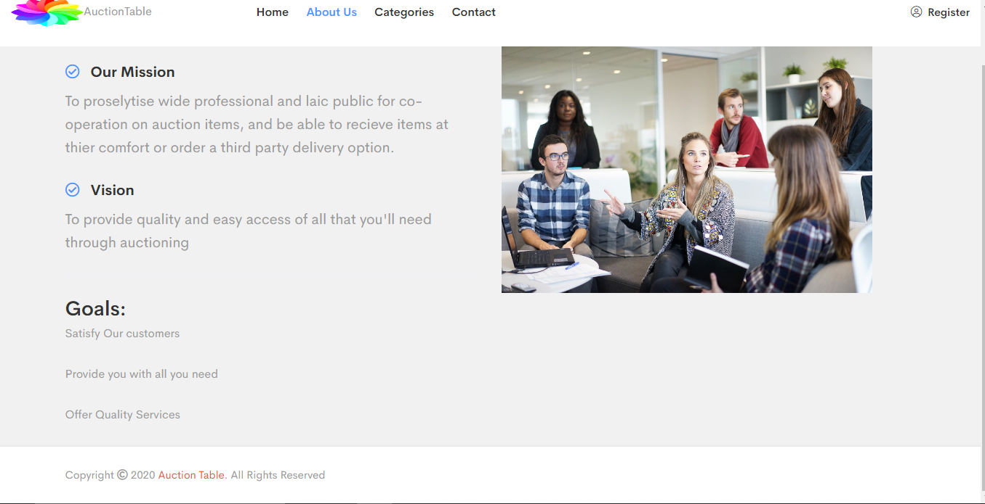

**SOURCE CODE**

**<div class="about-area about-pb" style="background-color: #f1f1f1;">**

**<div class="container">**

**<div class="row">**

**<div class="col-xl-6 col-lg-6">**

**<div class="about-wrapper pos-rel mb-30">**

**<div class="about-item">**

**<ul>**

**<li>**

**<div class="about-text">**

**<h4><i class="far fa-check-circle"></i>AuctionsTable</h4>**

**<p>AuctionsTable is an organization selling valuable items and goods through auctions.**

**They have a vast experience of organizing auctions for past 25 years.</p>**

**</div>**

**</li>**

**<li>**

**<div class="about-text">**

**<h4><i class="far fa-check-circle"></i>Our Mission</h4>**

**<p>To proselytise wide professional and laic public for co-operation**

**on auction items, and be able to recieve items at thier comfort or**

**order a third party delivery option.</p>**

**</div>**

**</li>**

**<li>**

**<div class="about-text">**

**<h4><i class="far fa-check-circle"></i>Vision</h4>**

**<p>To provide quality and easy access of all that you'll need through auctioning</p>**

**</div>**

**</li>**

**</ul>**

**<hr>**

**<h3>Goals:</h3>**

**<ul>**

**<li>Satisfy Our customers</li>**

**<li>Provide you with all you need</li>**

**<li>Offer Quality Services</li>**

**</ul>**

**</div>**

**</div>**

**</div>**

**<div class="col-xl-6 col-lg-6">**

**<div class="about-img pos-rel mb-30">**

**<img src="assets/img/banner/meeting-g64532ce56_1920.jpg" alt="">**

**</div>**

**</div>**

**</div>**

**</div>**

**</div>**

**<!-- about-area-end -->**

**<!-- footer-area-start -->**

**<footer>**

**<div class="footer-bottom-area pt-25 pb-25">**

**<div class="container">**

**<div class="row">**

**<div class="col-xl-6 col-lg-6 col-md-6">**

**<div class="copyright">**

**<p>Copyright <i class="far fa-copyright"></i> 2020 <a href="#">Auction Table</a>. All Rights Reserved</p>**

**</div>**

**</div>**

**</div>**

**</div>**

**</div>**

**</footer>**

**<!-- footer-area-end -->**

**<!-- JS here -->**

**<script src="assets/js/vendor/modernizr-3.5.0.min.js"></script>**

**<script src="assets/js/vendor/jquery-1.12.4.min.js"></script>**

**<script src="assets/js/popper.min.js"></script>**

**<script src="assets/js/bootstrap.min.js"></script>**

**<script src="assets/js/owl.carousel.min.js"></script>**

**<script src="assets/js/isotope.pkgd.min.js"></script>**

**<script src="assets/js/slick.min.js"></script>**

**<script src="assets/js/jquery.meanmenu.min.js"></script>**

**<script src="assets/js/ajax-form.js"></script>**

**<script src="assets/js/wow.min.js"></script>**

**<script src="assets/js/waypoints.min.js"></script>**

**<script src="assets/js/jquery.appear.js"></script>**

**<script src="assets/js/jquery.countdown.min.js"></script>**

**<script src="assets/js/jquery.knob.js"></script>**

**<script src="assets/js/jquery.counterup.min.js"></script>**

**<script src="assets/js/jquery.scrollUp.min.js"></script>**

**<script src="assets/js/imagesloaded.pkgd.min.js"></script>**

**<script src="assets/js/jquery.magnific-popup.min.js"></script>**

**<script src="assets/js/plugins.js"></script>**

**<script src="assets/js/main.js"></script>**

**CATEGORIES**

**FURNITURE**

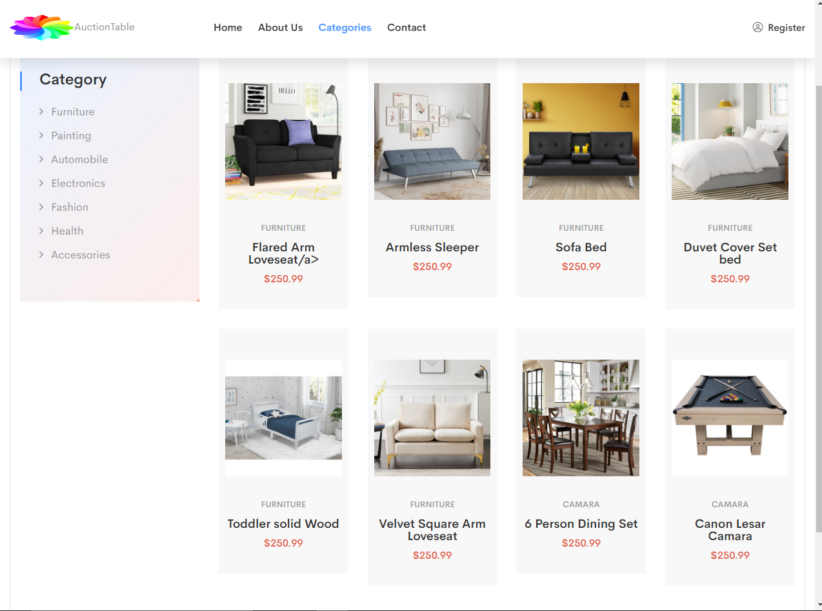

**SOURCE CODE**

**<!-- furniture-products-area-start -->**

**<div class="features-products-area fe-product pl-55 pr-55">**

**<div class="container-fluid">**

**<div class="fe-pro-border">**

**<div class="row">**

**<div class="col-xl-6 col-lg-6 offset-lg-3 offset-xl-3">**

**<div class="section-title text-center mb-65">**

**<h2>Furniture</h2>**

**</div>**

**</div>**

**</div>**

**<div class="row">**

**<div class="col-xl-3 col-lg-3 mb-30">**

**<div class="category-sidebar">**

**<h3 class="cat-title">Category</h3>**

**<div class="category-item">**

**<ul>**

**<li><a href="furniture.html">Furniture</a></li>**

**<li><a href="paintings.html">Painting</a></li>**

**<li><a href="automobile.html">Automobile</a></li>**

**<li><a href="electronics.html">Electronics</a></li>**

**<li><a href="fashion.html">Fashion</a></li>**

**<li><a href="health.html">Health</a></li>**

**<li><a href="accessories.html">Accessories</a></li>**

**</ul>**

**</div>**

**</div>**

**</div>**

**<div class="col-xl-9 col-lg-9">**

**<div class="row">**

**<div class="col-xl-3 cl-lg-3 col-md-6">**

**<div class="product-03-wrapper grey-2-bg pos-rel text-center mb-30">**

**<div class="product-02-img pos-rel">**

**<a href="loveseat.html">**

**<img src="assets/img/fashion/Flared+Arm+Loveseat 1.jpg" alt="">**

**</a>**

**</div>**

**<div class="product-text">**

**<h5>Furniture</h5>**

**<h4><a href="loveseat.html">Flared Arm Loveseat/a></h4>**

**<span>$250.99</span>**

**</div>**

**</div>**

**</div>**

**<div class="col-xl-3 cl-lg-3 col-md-6">**

**<div class="product-03-wrapper grey-2-bg pos-rel text-center mb-30">**

**<div class="product-02-img pos-rel">**

**<a href="armless.html">**

**<img src="assets/img/fashion/Armless+Sleeper 1.jpg" alt="">**

**</a>**

**</div>**

**<div class="product-text">**

**<h5>Furniture</h5>**

**<h4><a href="armless.html">Armless Sleeper</a></h4>**

**<span>$250.99</span>**

**</div>**

**</div>**

**</div>**

**<div class="col-xl-3 cl-lg-3 col-md-6">**

**<div class="product-03-wrapper grey-2-bg pos-rel text-center mb-30">**

**<div class="product-02-img pos-rel">**

**<a href="bed.html">**

**<img src="assets/img/fashion/Sofa+Bed 1.jpg" alt="">**

**</a>**

**</div>**

**<div class="product-text">**

**<h5>furniture</h5>**

**<h4><a href="bed.html">Sofa Bed</a></h4>**

**<span>$250.99</span>**

**</div>**

**</div>**

**</div>**

**<div class="col-xl-3 cl-lg-3 col-md-6">**

**<div class="product-03-wrapper grey-2-bg pos-rel text-center mb-30">**

**<div class="product-02-img pos-rel">**

**<a href="new.html">**

**<img src="assets/img/fashion/Duvet+Cover+Set bed 1.jpg" alt="">**

**</a>**

**</div>**

**<div class="product-text">**

**<h5>Furniture</h5>**

**<h4><a href="new.html">Duvet Cover Set bed</a></h4>**

**<span>$250.99</span>**

**</div>**

**</div>**

**</div>**

**<div class="col-xl-3 cl-lg-3 col-md-6">**

**<div class="product-03-wrapper grey-2-bg pos-rel text-center mb-30">**

**<div class="product-02-img pos-rel">**

**<a href="toddler.html">**

**<img src="assets/img/fashion/Toddler+Solid+Wood+Sleigh+Bed+by+Delta+Children 1.jpg" alt="">**

**</a>**

**</div>**

**<div class="product-text">**

**<h5>Furniture</h5>**

**<h4><a href="toddler.html">Toddler solid Wood</a></h4>**

**<span>$250.99</span>**

**</div>**

**</div>**

**</div>**

**<div class="col-xl-3 cl-lg-3 col-md-6">**

**<div class="product-03-wrapper grey-2-bg pos-rel text-center mb-30">**

**<div class="product-02-img pos-rel">**

**<a href="velvet.html">**

**<img src="assets/img/fashion/Velvet+Square+Arm+Loveseat 1.jpg" alt="">**

**</a>**

**</div>**

**<div class="product-text">**

**<h5>Furniture</h5>**

**<h4><a href="velvet.html">Velvet Square Arm Loveseat</a></h4>**

**<span>$250.99</span>**

**</div>**

**</div>**

**</div>**

**<div class="col-xl-3 cl-lg-3 col-md-6">**

**<div class="product-03-wrapper grey-2-bg pos-rel text-center mb-30">**

**<div class="product-02-img pos-rel">**

**<a href="nadine.html">**

**<img src="assets/img/fashion/Nadine+6+-+Person+Dining+Set 1.jpg" alt="">**

**</a>**

**</div>**

**<div class="product-text">**

**<h5>camara</h5>**

**<h4><a href="nadine.html">6 Person Dining Set</a></h4>**

**<span>$250.99</span>**

**</div>**

**</div>**

**</div>**

**<div class="col-xl-3 cl-lg-3 col-md-6">**

**<div class="product-03-wrapper grey-2-bg pos-rel text-center mb-30">**

**<div class="product-02-img pos-rel">**

**<a href="american.html">**

**<img src="assets/img/fashion/American+Legend+84_+Bayville+Billiard+Table 1.jpg" alt="">**

**</a>**

**</div>**

**<div class="product-text">**

**<h5>camara</h5>**

**<h4><a href="american.html">Canon Lesar Camara</a></h4>**

**<span>$250.99</span>**

**</div>**

**</div>**

**</div>**

**</div>**

**</div>**

**</div>**

**</div>**

**</div>**

**</div>**

**<!-- furniture-products-area-end -->**

**<!-- footer-area-start -->**

**<footer>**

**<div class="footer-bottom-area pt-25 pb-25">**

**<div class="container">**

**<div class="row">**

**<div class="col-xl-6 col-lg-6 col-md-6">**

**<div class="copyright">**

**<p>Copyright <i class="far fa-copyright"></i> 2020 <a href="#">Auction Table</a>. All Rights Reserved</p>**

**</div>**

**</div>**

**</div>**

**</div>**

**</div>**

**</footer>**

**<!-- footer-area-end -->**

**<!-- JS here -->**

**<script src="assets/js/vendor/modernizr-3.5.0.min.js"></script>**

**<script src="assets/js/vendor/jquery-1.12.4.min.js"></script>**

**<script src="assets/js/popper.min.js"></script>**

**<script src="assets/js/bootstrap.min.js"></script>**

**<script src="assets/js/owl.carousel.min.js"></script>**

**<script src="assets/js/isotope.pkgd.min.js"></script>**

**<script src="assets/js/slick.min.js"></script>**

**<script src="assets/js/jquery.meanmenu.min.js"></script>**

**<script src="assets/js/ajax-form.js"></script>**

**<script src="assets/js/wow.min.js"></script>**

**<script src="assets/js/waypoints.min.js"></script>**

**<script src="assets/js/jquery.appear.js"></script>**

**<script src="assets/js/jquery.countdown.min.js"></script>**

**<script src="assets/js/jquery.knob.js"></script>**

**<script src="assets/js/jquery.counterup.min.js"></script>**

**<script src="assets/js/jquery.scrollUp.min.js"></script>**

**<script src="assets/js/imagesloaded.pkgd.min.js"></script>**

**<script src="assets/js/jquery.magnific-popup.min.js"></script>**

**<script src="assets/js/plugins.js"></script>**

**<script src="assets/js/main.js"></script>**

**PAINTINGS**

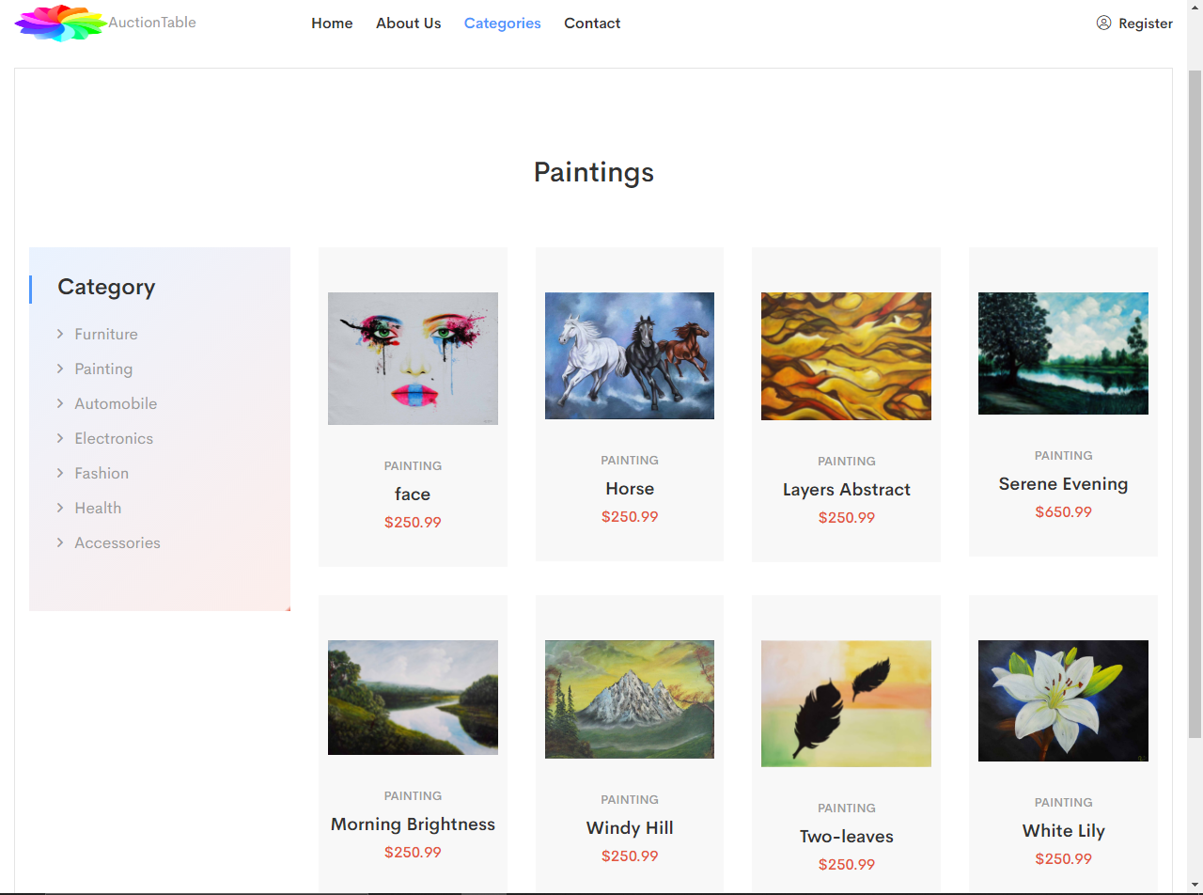

**SOURCE CODE**

**<!-- PAINTINGS-area-start -->**

**<div class="features-products-area fe-product pl-55 pr-55">**

**<div class="container-fluid">**

**<div class="fe-pro-border">**

**<div class="row">**

**<div class="col-xl-6 col-lg-6 offset-lg-3 offset-xl-3">**

**<div class="section-title text-center mb-65">**

**<h2>Paintings</h2>**

**</div>**

**</div>**

**</div>**

**<div class="row">**

**<div class="col-xl-3 col-lg-3 mb-30">**

**<div class="category-sidebar">**

**<h3 class="cat-title">Category</h3>**

**<div class="category-item">**

**<ul>**

**<li><a href="furniture.html">Furniture</a></li>**

**<li><a href="paintings.html">Painting</a></li>**

**<li><a href="automobile.html">Automobile</a></li>**

**<li><a href="electronics.html">Electronics</a></li>**

**<li><a href="fashion.html">Fashion</a></li>**

**<li><a href="health.html">Health</a></li>**

**<li><a href="accessories.html">Accessories</a></li>**

**</ul>**

**</div>**

**</div>**

**</div>**

**<div class="col-xl-9 col-lg-9">**

**<div class="row">**

**<div class="col-xl-3 cl-lg-3 col-md-6">**

**<div class="product-03-wrapper grey-2-bg pos-rel text-center mb-30">**

**<div class="product-02-img pos-rel">**

**<a href="face.html">**

**<img src="assets/img/paintings/face 1.jpg" alt="">**

**</a>**

**</div>**

**<div class="product-text">**

**<h5>painting</h5>**

**<h4><a href="face.html">face</a></h4>**

**<span>$250.99</span>**

**</div>**

**</div>**

**</div>**

**<div class="col-xl-3 cl-lg-3 col-md-6">**

**<div class="product-03-wrapper grey-2-bg pos-rel text-center mb-30">**

**<div class="product-02-img pos-rel">**

**<a href="horse.html">**

**<img src="assets/img/paintings/horse 1.jpg" alt="">**

**</a>**

**</div>**

**<div class="product-text">**

**<h5>painting</h5>**

**<h4><a href="horse.html">Horse</a></h4>**

**<span>$250.99</span>**

**</div>**

**</div>**

**</div>**

**<div class="col-xl-3 cl-lg-3 col-md-6">**

**<div class="product-03-wrapper grey-2-bg pos-rel text-center mb-30">**

**<div class="product-02-img pos-rel">**

**<a href="layers abstract.html">**

**<img src="assets/img/paintings/layers abstract 1.jpg" alt="">**

**</a>**

**</div>**

**<div class="product-text">**

**<h5>painting</h5>**

**<h4><a href="layers abstract.html">Layers Abstract</a></h4>**

**<span>$250.99</span>**

**</div>**

**</div>**

**</div>**

**<div class="col-xl-3 cl-lg-3 col-md-6">**

**<div class="product-03-wrapper grey-2-bg pos-rel text-center mb-30">**

**<div class="product-02-img pos-rel">**

**<a href="serene.html">**

**<img src="assets/img/paintings/serene evening 1.jpg" alt="">**

**</a>**

**</div>**

**<div class="product-text">**

**<h5>painting</h5>**

**<h4><a href="serene.html">Serene Evening</a></h4>**

**<span>$650.99</span>**

**</div>**

**</div>**

**</div>**

**<div class="col-xl-3 cl-lg-3 col-md-6">**

**<div class="product-03-wrapper grey-2-bg pos-rel text-center mb-30">**

**<div class="product-02-img pos-rel">**

**<a href="morning.html">**

**<img src="assets/img/paintings/morning brightness 1.jpg" alt="">**

**</a>**

**</div>**

**<div class="product-text">**

**<h5>painting</h5>**

**<h4><a href="morning.html">Morning Brightness</a></h4>**

**<span>$250.99</span>**

**</div>**

**</div>**

**</div>**

**<div class="col-xl-3 cl-lg-3 col-md-6">**

**<div class="product-03-wrapper grey-2-bg pos-rel text-center mb-30">**

**<div class="product-02-img pos-rel">**

**<a href="mount.html">**

**<img src="assets/img/paintings/mount 1.jpg" alt="">**

**</a>**

**</div>**

**<div class="product-text">**

**<h5>painting</h5>**

**<h4><a href="mount.html">Windy Hill</a></h4>**

**<span>$250.99</span>**

**</div>**

**</div>**

**</div>**

**<div class="col-xl-3 cl-lg-3 col-md-6">**

**<div class="product-03-wrapper grey-2-bg pos-rel text-center mb-30">**

**<div class="product-02-img pos-rel">**

**<a href="two-leaves.html">**

**<img src="assets/img/paintings/two leaves.jpg" alt="">**

**</a>**

**</div>**

**<div class="product-text">**

**<h5>painting</h5>**

**<h4><a href="two-leaves.html">Two-leaves</a></h4>**

**<span>$250.99</span>**

**</div>**

**</div>**

**</div>**

**<div class="col-xl-3 cl-lg-3 col-md-6">**

**<div class="product-03-wrapper grey-2-bg pos-rel text-center mb-30">**

**<div class="product-02-img pos-rel">**

**<a href="white-flower.html">**

**<img src="assets/img/paintings/white flower 1.jpg" alt="">**

**</a>**

**</div>**

**<div class="product-text">**

**<h5>painting</h5>**

**<h4><a href="white-flower.html">White Lily</a></h4>**

**<span>$250.99</span>**

**</div>**

**</div>**

**</div>**

**</div>**

**</div>**

**</div>**

**</div>**

**</div>**

**</div>**

**<!-- PAINTINGS-area-end -->**

**<!-- footer-area-start -->**

**<footer>**

**<div class="footer-bottom-area pt-25 pb-25">**

**<div class="container">**

**<div class="row">**

**<div class="col-xl-6 col-lg-6 col-md-6">**

**<div class="copyright">**

**<p>Copyright <i class="far fa-copyright"></i> 2020 <a href="#">Auction Table</a>. All Rights Reserved</p>**

**</div>**

**</div>**

**</div>**

**</div>**

**</div>**

**</footer>**

**<!-- footer-area-end -->**

**<!-- JS here -->**

**<script src="assets/js/vendor/modernizr-3.5.0.min.js"></script>**

**<script src="assets/js/vendor/jquery-1.12.4.min.js"></script>**

**<script src="assets/js/popper.min.js"></script>**

**<script src="assets/js/bootstrap.min.js"></script>**

**<script src="assets/js/owl.carousel.min.js"></script>**

**<script src="assets/js/isotope.pkgd.min.js"></script>**

**<script src="assets/js/slick.min.js"></script>**

**<script src="assets/js/jquery.meanmenu.min.js"></script>**

**<script src="assets/js/ajax-form.js"></script>**

**<script src="assets/js/wow.min.js"></script>**

**<script src="assets/js/waypoints.min.js"></script>**

**<script src="assets/js/jquery.appear.js"></script>**

**<script src="assets/js/jquery.countdown.min.js"></script>**

**<script src="assets/js/jquery.knob.js"></script>**

**<script src="assets/js/jquery.counterup.min.js"></script>**

**<script src="assets/js/jquery.scrollUp.min.js"></script>**

**<script src="assets/js/imagesloaded.pkgd.min.js"></script>**

**<script src="assets/js/jquery.magnific-popup.min.js"></script>**

**<script src="assets/js/plugins.js"></script>**

**<script src="assets/js/main.js"></script>**

**AUTOMOBILE**

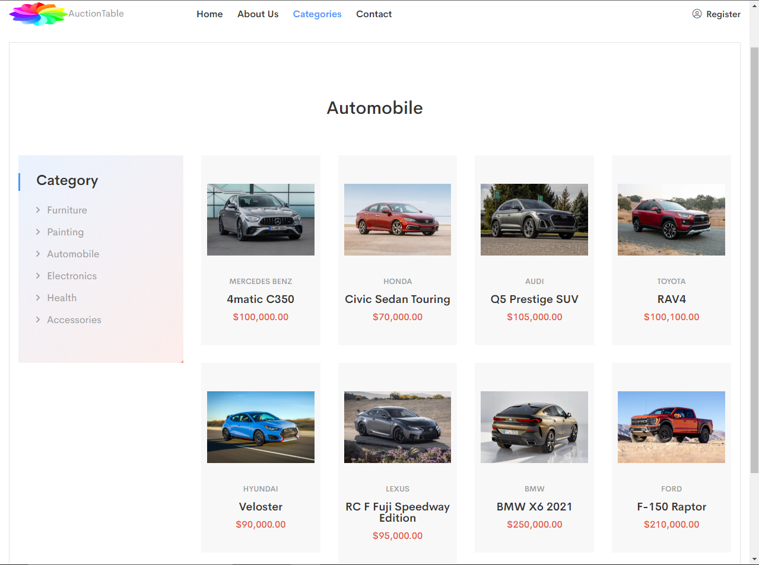

**SOURCE CODE**

**<!-- AUTOMOBILE--area-start -->**

**<div class="features-products-area fe-product pl-55 pr-55">**

**<div class="container-fluid">**

**<div class="fe-pro-border">**

**<div class="row">**

**<div class="col-xl-6 col-lg-6 offset-lg-3 offset-xl-3">**

**<div class="section-title text-center mb-65">**

**<h2>Automobile</h2>**

**</div>**

**</div>**

**</div>**

**<div class="row">**

**<div class="col-xl-3 col-lg-3 mb-30">**

**<div class="category-sidebar">**

**<h3 class="cat-title">Category</h3>**

**<div class="category-item">**

**<ul>**

**<li><a href="furniture.html">Furniture</a></li>**

**<li><a href="paintings.html">Painting</a></li>**

**<li><a href="automobile.html">Automobile</a></li>**

**<li><a href="electronics.html">Electronics</a></li>**

**<li><a href="health.html">Health</a></li>**

**<li><a href="accessories.html">Accessories</a></li>**

**</ul>**

**</div>**

**</div>**

**</div>**

**<div class="col-xl-9 col-lg-9">**

**<div class="row">**

**<div class="col-xl-3 cl-lg-3 col-md-6">**

**<div class="product-03-wrapper grey-2-bg pos-rel text-center mb-30">**

**<div class="product-02-img pos-rel">**

**<a href="benz_4matic.html">**

**<img src="assets/img/cars/benz1.jpg" alt="">**

**</a>**

**</div>**

**<div class="product-text">**

**<h5>mercedes benz</h5>**

**<h4><a href="benz_4matic.html">4matic C350</a></h4>**

**<span>$100,000.00</span>**

**</div>**

**</div>**

**</div>**

**<div class="col-xl-3 cl-lg-3 col-md-6">**

**<div class="product-03-wrapper grey-2-bg pos-rel text-center mb-30">**

**<div class="product-02-img pos-rel">**

**<a href="honda.html">**

**<img src="assets/img/cars/2021_honda_civic_sedan_touring1.jpg" alt="">**

**</a>**

**</div>**

**<div class="product-text">**

**<h5>honda</h5>**

**<h4><a href="honda.html">Civic Sedan Touring</a></h4>**

**<span>$70,000.00</span>**

**</div>**

**</div>**

**</div>**

**<div class="col-xl-3 cl-lg-3 col-md-6">**

**<div class="product-03-wrapper grey-2-bg pos-rel text-center mb-30">**

**<div class="product-02-img pos-rel">**

**<a href="audi.html">**

**<img src="assets/img/cars/audiq5_2.jpg" alt="">**

**</a>**

**</div>**

**<div class="product-text">**

**<h5>Audi</h5>**

**<h4><a href="audi.html">Q5 Prestige SUV</a></h4>**

**<span>$105,000.00</span>**

**</div>**

**</div>**

**</div>**

**<div class="col-xl-3 cl-lg-3 col-md-6">**

**<div class="product-03-wrapper grey-2-bg pos-rel text-center mb-30">**

**<div class="product-02-img pos-rel">**

**<a href="toyota.html">**

**<img src="assets/img/cars/toyata_rav4_1.jpg" alt="">**

**</a>**

**</div>**

**<div class="product-text">**

**<h5>Toyota</h5>**

**<h4><a href="toyota.html">RAV4</a></h4>**

**<span>$100,100.00</span>**

**</div>**

**</div>**

**</div>**

**<div class="col-xl-3 cl-lg-3 col-md-6">**

**<div class="product-03-wrapper grey-2-bg pos-rel text-center mb-30">**

**<div class="product-02-img pos-rel">**

**<a href="hyundai.html">**

**<img src="assets/img/cars/hyundai_veloster3.jpg" alt="">**

**</a>**

**</div>**

**<div class="product-text">**

**<h5>Hyundai</h5>**

**<h4><a href="hyundai.html">Veloster</a></h4>**

**<span>$90,000.00</span>**

**</div>**

**</div>**

**</div>**

**<div class="col-xl-3 cl-lg-3 col-md-6">**

**<div class="product-03-wrapper grey-2-bg pos-rel text-center mb-30">**

**<div class="product-02-img pos-rel">**

**<a href="lexus.html">**

**<img src="assets/img/cars/lexus3.jpg" alt="">**

**</a>**

**</div>**

**<div class="product-text">**

**<h5>lexus</h5>**

**<h4><a href="lexus.html">RC F Fuji Speedway Edition</a></h4>**

**<span>$95,000.00</span>**

**</div>**

**</div>**

**</div>**

**<div class="col-xl-3 cl-lg-3 col-md-6">**

**<div class="product-03-wrapper grey-2-bg pos-rel text-center mb-30">**

**<div class="product-02-img pos-rel">**

**<a href="bmw.html">**

**<img src="assets/img/cars/bmw.jpg" alt="">**

**</a>**

**</div>**

**<div class="product-text">**

**<h5>bmw</h5>**

**<h4><a href="bmw.html">BMW X6 2021</a></h4>**

**<span>$250,000.00</span>**

**</div>**

**</div>**

**</div>**

**<div class="col-xl-3 cl-lg-3 col-md-6">**

**<div class="product-03-wrapper grey-2-bg pos-rel text-center mb-30">**

**<div class="product-02-img pos-rel">**

**<a href="ford.html">**

**<img src="assets/img/cars/fordraptor2.jpg" alt="">**

**</a>**

**</div>**

**<div class="product-text">**

**<h5>ford</h5>**

**<h4><a href="ford.html">F-150 Raptor</a></h4>**

**<span>$210,000.00</span>**

**</div>**

**</div>**

**</div>**

**</div>**

**</div>**

**</div>**

**</div>**

**</div>**

**</div>**

**<!-- AUTOMOBILE-products-area-end -->**

**<!-- footer-area-start -->**

**<footer>**

**<div class="footer-bottom-area pt-25 pb-25">**

**<div class="container">**

**<div class="row">**

**<div class="col-xl-6 col-lg-6 col-md-6">**

**<div class="copyright">**

**<p>Copyright <i class="far fa-copyright"></i> 2020 <a href="#">Auction Table</a>. All Rights Reserved</p>**

**</div>**

**</div>**

**</div>**

**</div>**

**</div>**

**</footer>**

**<!-- footer-area-end -->**

**<!-- JS here -->**

**<script src="assets/js/vendor/modernizr-3.5.0.min.js"></script>**

**<script src="assets/js/vendor/jquery-1.12.4.min.js"></script>**

**<script src="assets/js/popper.min.js"></script>**

**<script src="assets/js/bootstrap.min.js"></script>**

**<script src="assets/js/owl.carousel.min.js"></script>**

**<script src="assets/js/isotope.pkgd.min.js"></script>**

**<script src="assets/js/slick.min.js"></script>**

**<script src="assets/js/jquery.meanmenu.min.js"></script>**

**<script src="assets/js/ajax-form.js"></script>**

**<script src="assets/js/wow.min.js"></script>**

**<script src="assets/js/waypoints.min.js"></script>**

**<script src="assets/js/jquery.appear.js"></script>**

**<script src="assets/js/jquery.countdown.min.js"></script>**

**<script src="assets/js/jquery.knob.js"></script>**

**<script src="assets/js/jquery.counterup.min.js"></script>**

**<script src="assets/js/jquery.scrollUp.min.js"></script>**

**<script src="assets/js/imagesloaded.pkgd.min.js"></script>**

**<script src="assets/js/jquery.magnific-popup.min.js"></script>**

**<script src="assets/js/plugins.js"></script>**

**<script src="assets/js/main.js"></script>**

**ELECTRONICS**

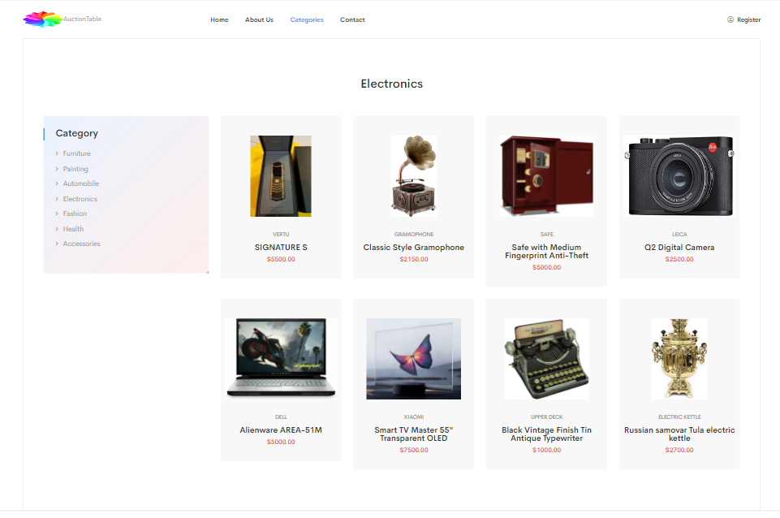

**SOURCE CODE**

**<!-- ELECTRONICS-products-area-start -->**

**<div class="features-products-area fe-product pl-55 pr-55">**

**<div class="container-fluid">**

**<div class="fe-pro-border">**

**<div class="row">**

**<div class="col-xl-6 col-lg-6 offset-lg-3 offset-xl-3">**

**<div class="section-title text-center mb-65">**

**<h2>Electronics</h2>**

**</div>**

**</div>**

**</div>**

**<div class="row">**

**<div class="col-xl-3 col-lg-3 mb-30">**

**<div class="category-sidebar">**

**<h3 class="cat-title">Category</h3>**

**<div class="category-item">**

**<ul>**

**<li><a href="furniture.html">Furniture</a></li>**

**<li><a href="paintings.html">Painting</a></li>**

**<li><a href="automobile.html">Automobile</a></li>**

**<li><a href="electronics.html">Electronics</a></li>**

**<li><a href="fashion.html">Fashion</a></li>**

**<li><a href="health.html">Health</a></li>**

**<li><a href="accessories.html">Accessories</a></li>**

**</ul>**

**</div>**

**</div>**

**</div>**

**<div class="col-xl-9 col-lg-9">**

**<div class="row">**

**<div class="col-xl-3 cl-lg-3 col-md-6">**

**<div class="product-03-wrapper grey-2-bg pos-rel text-center mb-30">**

**<div class="product-02-img pos-rel">**

**<a href="vertu.html">**

**<img src="assets/img/electronics/vertu_signature1.jpg" class="pop" alt="">**

**</a>**

**</div>**

**<div class="product-text">**

**<h5>vertu</h5>**

**<h4><a href="vertu.html">SIGNATURE S</a></h4>**

**<span>$5500.00</span>**

**</div>**

**</div>**

**</div>**

**<div class="col-xl-3 cl-lg-3 col-md-6">**

**<div class="product-03-wrapper grey-2-bg pos-rel text-center mb-30">**

**<div class="product-02-img pos-rel">**

**<a href="gramophone.html">**

**<img src="assets/img/electronics/gramophone1.jpg" class="pop" alt="">**

**</a>**

**</div>**

**<div class="product-text">**

**<h5>gramophone</h5>**

**<h4><a href="gramophone.html">Classic Style Gramophone</a></h4>**

**<span>$2150.00</span>**

**</div>**

**</div>**

**</div>**

**<div class="col-xl-3 cl-lg-3 col-md-6">**

**<div class="product-03-wrapper grey-2-bg pos-rel text-center mb-30">**

**<div class="product-02-img pos-rel">**

**<a href="safe.html">**

**<img src="assets/img/electronics/safe1.jpg" class="pop" alt="">**

**</a>**

**</div>**

**<div class="product-text">**

**<h5>Safe</h5>**

**<h4><a href="safe.html">Safe with Medium Fingerprint Anti-Theft</a></h4>**

**<span>$5000.00</span>**

**</div>**

**</div>**

**</div>**

**<div class="col-xl-3 cl-lg-3 col-md-6">**

**<div class="product-03-wrapper grey-2-bg pos-rel text-center mb-30">**

**<div class="product-02-img pos-rel">**

**<a href="camera.html">**

**<img src="assets/img/electronics/camera1.jpg" class="pop" alt="">**

**</a>**

**</div>**

**<div class="product-text">**

**<h5>Leica</h5>**

**<h4><a href="camera.html">Q2 Digital Camera</a></h4>**

**<span>$2500.00</span>**

**</div>**

**</div>**

**</div>**

**<div class="col-xl-3 cl-lg-3 col-md-6">**

**<div class="product-03-wrapper grey-2-bg pos-rel text-center mb-30">**

**<div class="product-02-img pos-rel">**

**<a href="laptop.html">**

**<img src="assets/img/electronics/laptop1.jpg" class="pop" alt="">**

**</a>**

**</div>**

**<div class="product-text">**

**<h5>Dell</h5>**

**<h4><a href="laptop.html">Alienware AREA-51M</a></h4>**

**<span>$5000.00</span>**

**</div>**

**</div>**

**</div>**

**<div class="col-xl-3 cl-lg-3 col-md-6">**

**<div class="product-03-wrapper grey-2-bg pos-rel text-center mb-30">**

**<div class="product-02-img pos-rel">**

**<a href="tv.html">**

**<img src="assets/img/electronics/tv1.jpg" class="pop" alt="">**

**</a>**

**</div>**

**<div class="product-text">**

**<h5>Xiaomi</h5>**

**<h4><a href="tv.html">Smart TV Master 55" Transparent OLED</a></h4>**

**<span>$7500.00</span>**

**</div>**

**</div>**

**</div>**

**<div class="col-xl-3 cl-lg-3 col-md-6">**

**<div class="product-03-wrapper grey-2-bg pos-rel text-center mb-30">**

**<div class="product-02-img pos-rel">**

**<a href="typewritter.html">**

**<img src="assets/img/electronics/typewriter.jpg" class="pop" alt="">**

**</a>**

**</div>**

**<div class="product-text">**

**<h5>Upper Deck</h5>**

**<h4><a href="typewritter.html">Black Vintage Finish Tin Antique Typewriter</a></h4>**

**<span>$1000.00</span>**

**</div>**

**</div>**

**</div>**

**<div class="col-xl-3 cl-lg-3 col-md-6">**

**<div class="product-03-wrapper grey-2-bg pos-rel text-center mb-30">**

**<div class="product-02-img pos-rel">**

**<a href="kettle.html">**

**<img src="assets/img/electronics/kettle2.jpg" class="pop" alt="">**

**</a>**

**</div>**

**<div class="product-text">**

**<h5>Electric kettle</h5>**

**<h4><a href="kettle.html">Russian samovar Tula electric kettle</a></h4>**

**<span>$2700.00</span>**

**</div>**

**</div>**

**</div>**

**</div>**

**</div>**

**</div>**

**</div>**

**</div>**

**</div>**

**<!-- ELECTRONICS-products-area-end -->**

**<!-- footer-area-start -->**

**<footer>**

**<div class="footer-bottom-area pt-25 pb-25">**

**<div class="container">**

**<div class="row">**

**<div class="col-xl-6 col-lg-6 col-md-6">**

**<div class="copyright">**

**<p>Copyright <i class="far fa-copyright"></i> 2020 <a href="#">Auction Table</a>. All Rights Reserved</p>**

**</div>**

**</div>**

**</div>**

**</div>**

**</div>**

**</footer>**

**<!-- footer-area-end -->**

**<!-- JS here -->**

**<script src="assets/js/vendor/modernizr-3.5.0.min.js"></script>**

**<script src="assets/js/vendor/jquery-1.12.4.min.js"></script>**

**<script src="assets/js/popper.min.js"></script>**

**<script src="assets/js/bootstrap.min.js"></script>**

**<script src="assets/js/owl.carousel.min.js"></script>**

**<script src="assets/js/isotope.pkgd.min.js"></script>**

**<script src="assets/js/slick.min.js"></script>**

**<script src="assets/js/jquery.meanmenu.min.js"></script>**

**<script src="assets/js/ajax-form.js"></script>**

**<script src="assets/js/wow.min.js"></script>**

**<script src="assets/js/waypoints.min.js"></script>**

**<script src="assets/js/jquery.appear.js"></script>**

**<script src="assets/js/jquery.countdown.min.js"></script>**

**<script src="assets/js/jquery.knob.js"></script>**

**<script src="assets/js/jquery.counterup.min.js"></script>**

**<script src="assets/js/jquery.scrollUp.min.js"></script>**

**<script src="assets/js/imagesloaded.pkgd.min.js"></script>**

**<script src="assets/js/jquery.magnific-popup.min.js"></script>**

**<script src="assets/js/plugins.js"></script>**

**<script src="assets/js/main.js"></script>**

**FASHION**

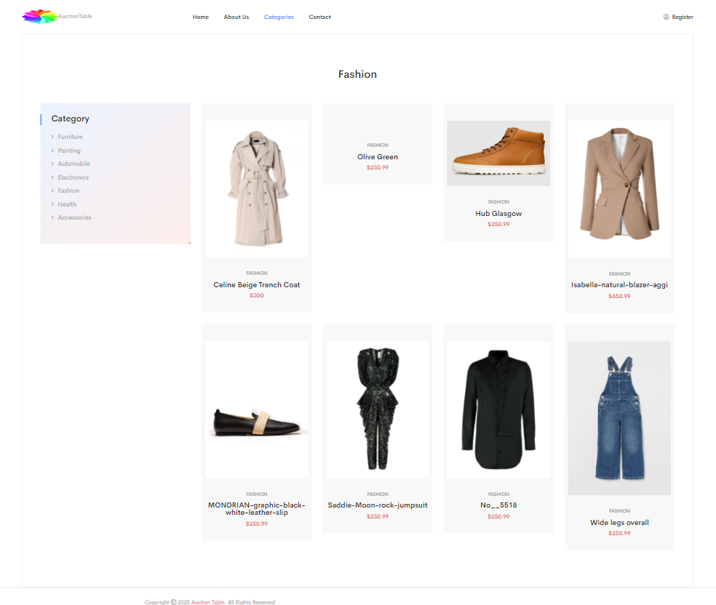

**SOURCE CODE**

**<!-- FASHION-area-start -->**

**<div class="features-products-area fe-product pl-55 pr-55">**

**<div class="container-fluid">**

**<div class="fe-pro-border">**

**<div class="row">**

**<div class="col-xl-6 col-lg-6 offset-lg-3 offset-xl-3">**

**<div class="section-title text-center mb-65">**

**<h2>Fashion</h2>**

**</div>**

**</div>**

**</div>**

**<div class="row">**

**<div class="col-xl-3 col-lg-3 mb-30">**

**<div class="category-sidebar">**

**<h3 class="cat-title">Category</h3>**

**<div class="category-item">**

**<ul>**

**<li><a href="furniture.html">Furniture</a></li>**

**<li><a href="paintings.html">Painting</a></li>**

**<li><a href="automobile.html">Automobile</a></li>**

**<li><a href="electronics.html">Electronics</a></li>**

**<li><a href="fashion.html">Fashion</a></li>**

**<li><a href="health.html">Health</a></li>**

**<li><a href="accessories.html">Accessories</a></li>**

**</ul>**

**</div>**

**</div>**

**</div>**

**<div class="col-xl-9 col-lg-9">**

**<div class="row">**

**<div class="col-xl-3 cl-lg-3 col-md-6">**

**<div class="product-03-wrapper grey-2-bg pos-rel text-center mb-30">**

**<div class="product-02-img pos-rel">**

**<a href="celine.html">**

**<img src="assets/img/fashion/Celine-Beige-Trech-Coat 1.jpg" alt="">**

**</a>**

**</div>**

**<div class="product-text">**

**<h5>Fashion</h5>**

**<h4><a href="celine.html">Celine Beige Trench Coat</a></h4>**

**<span>$300</span>**

**</div>**

**</div>**

**</div>**

**<div class="col-xl-3 cl-lg-3 col-md-6">**

**<div class="product-03-wrapper grey-2-bg pos-rel text-center mb-30">**

**<div class="product-02-img pos-rel">**

**<a href="olive.html">**

**<img src="assets/img/fashion/olive green 1" alt="">**

**</a>**

**</div>**

**<div class="product-text">**

**<h5>Fashion</h5>**

**<h4><a href="olive.html">Olive Green</a></h4>**

**<span>$250.99</span>**

**</div>**

**</div>**

**</div>**

**<div class="col-xl-3 cl-lg-3 col-md-6">**

**<div class="product-03-wrapper grey-2-bg pos-rel text-center mb-30">**

**<div class="product-02-img pos-rel">**

**<a href="hub.html">**

**<img src="assets/img/fashion/hub_h_glasgow_1.jpg" alt="">**

**</a>**

**</div>**

**<div class="product-text">**

**<h5>Fashion</h5>**

**<h4><a href="hub.html">Hub Glasgow</a></h4>**

**<span>$250.99</span>**

**</div>**

**</div>**

**</div>**

**<div class="col-xl-3 cl-lg-3 col-md-6">**

**<div class="product-03-wrapper grey-2-bg pos-rel text-center mb-30">**

**<div class="product-02-img pos-rel">**

**<a href="isabella.html">**

**<img src="assets/img/fashion/Isabella-natural-blazer-agg1 1.jpg" alt="">**

**</a>**

**</div>**

**<div class="product-text">**

**<h5>Fashion</h5>**

**<h4><a href="isabella.html">Isabella-natural-blazer-aggi</a></h4>**

**<span>$650.99</span>**

**</div>**

**</div>**

**</div>**

**<div class="col-xl-3 cl-lg-3 col-md-6">**

**<div class="product-03-wrapper grey-2-bg pos-rel text-center mb-30">**

**<div class="product-02-img pos-rel">**

**<a href="mondrian.html">**

**<img src="assets/img/fashion/MONDRIAN-graphic-black-white-leather-slip 1.jpg" alt="">**

**</a>**

**</div>**

**<div class="product-text">**

**<h5>Fashion</h5>**

**<h4><a href="mondrian.html">MONDRIAN-graphic-black-white-leather-slip</a></h4>**

**<span>$250.99</span>**

**</div>**

**</div>**

**</div>**

**<div class="col-xl-3 cl-lg-3 col-md-6">**

**<div class="product-03-wrapper grey-2-bg pos-rel text-center mb-30">**

**<div class="product-02-img pos-rel">**

**<a href="saddie.html">**

**<img src="assets/img/fashion/Saddie-Moon-rock-jumpsuit 1.jpg" alt="">**

**</a>**

**</div>**

**<div class="product-text">**

**<h5>Fashion</h5>**

**<h4><a href="saddie.html">Saddie-Moon-rock-jumpsuit</a></h4>**

**<span>$250.99</span>**

**</div>**

**</div>**

**</div>**

**<div class="col-xl-3 cl-lg-3 col-md-6">**

**<div class="product-03-wrapper grey-2-bg pos-rel text-center mb-30">**

**<div class="product-02-img pos-rel">**

**<a href="U.Mi.html">**

**<img src="assets/img/fashion/U.Mi-1-Scarf-Shirt 1.jpg" alt="">**

**</a>**

**</div>**

**<div class="product-text">**

**<h5>Fashion</h5>**

**<h4><a href="U.Mi.html">No__5518</a></h4>**

**<span>$250.99</span>**

**</div>**

**</div>**

**</div>**

**<div class="col-xl-3 cl-lg-3 col-md-6">**

**<div class="product-03-wrapper grey-2-bg pos-rel text-center mb-30">**

**<div class="product-02-img pos-rel">**

**<a href="wide.html">**

**<img src="assets/img/fashion/wide-legs-overall 1.jpeg" alt="">**

**</a>**

**</div>**

**<div class="product-text">**

**<h5>Fashion</h5>**

**<h4><a href="wide.html">Wide legs overall</a></h4>**

**<span>$250.99</span>**

**</div>**

**</div>**

**</div>**

**</div>**

**</div>**

**</div>**

**</div>**

**</div>**

**</div>**

**<!-- FASHION-area-end -->**

**<!-- footer-area-start -->**

**<footer>**

**<div class="footer-bottom-area pt-25 pb-25">**

**<div class="container">**

**<div class="row">**

**<div class="col-xl-6 col-lg-6 col-md-6">**

**<div class="copyright">**

**<p>Copyright <i class="far fa-copyright"></i> 2020 <a href="#">Auction Table</a>. All Rights Reserved</p>**

**</div>**

**</div>**

**</div>**

**</div>**

**</div>**

**</footer>**

**<!-- footer-area-end -->**

**<!-- JS here -->**

**<script src="assets/js/vendor/modernizr-3.5.0.min.js"></script>**

**<script src="assets/js/vendor/jquery-1.12.4.min.js"></script>**

**<script src="assets/js/popper.min.js"></script>**

**<script src="assets/js/bootstrap.min.js"></script>**

**<script src="assets/js/owl.carousel.min.js"></script>**

**<script src="assets/js/isotope.pkgd.min.js"></script>**

**<script src="assets/js/slick.min.js"></script>**

**<script src="assets/js/jquery.meanmenu.min.js"></script>**

**<script src="assets/js/ajax-form.js"></script>**

**<script src="assets/js/wow.min.js"></script>**

**<script src="assets/js/waypoints.min.js"></script>**

**<script src="assets/js/jquery.appear.js"></script>**

**<script src="assets/js/jquery.countdown.min.js"></script>**

**<script src="assets/js/jquery.knob.js"></script>**

**<script src="assets/js/jquery.counterup.min.js"></script>**

**<script src="assets/js/jquery.scrollUp.min.js"></script>**

**<script src="assets/js/imagesloaded.pkgd.min.js"></script>**

**<script src="assets/js/jquery.magnific-popup.min.js"></script>**

**<script src="assets/js/plugins.js"></script>**

**<script src="assets/js/main.js"></script>**

**HEALTH**

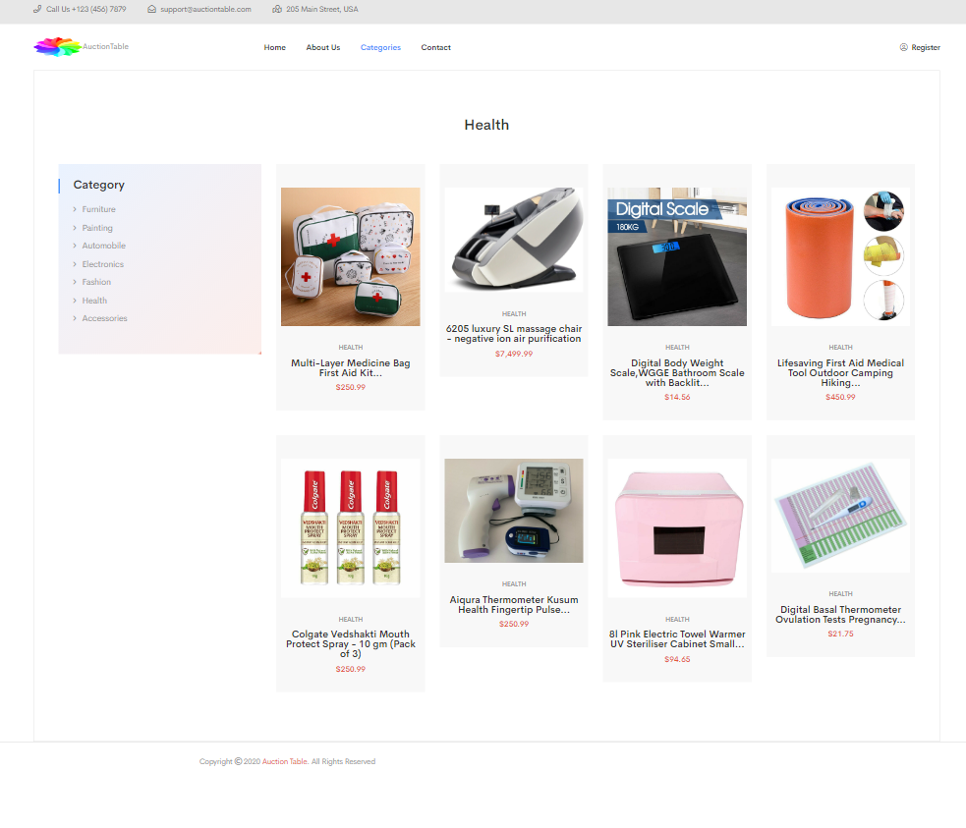

**SOURCE CODE**

<!-- HEALTH-area-start -->

             <div class="features-products-area fe-product pl-55 pr-55">

                <div class="container-fluid">

                    <div class="fe-pro-border">

                        <div class="row">

                            <div class="col-xl-6 col-lg-6 offset-lg-3 offset-xl-3">

                                <div class="section-title text-center mb-65">

                                    <h2>Health</h2>

                                </div>

                            </div>

                        </div>

                        <div class="row">

                            <div class="col-xl-3 col-lg-3 mb-30">

                                <div class="category-sidebar">

                                    <h3 class="cat-title">Category</h3>

                                    <div class="category-item">

                                        <ul>

                                            <li><a href="furniture.html">Furniture</a></li>

                                            <li><a href="paintings.html">Painting</a></li>

                                            <li><a href="automobile.html">Automobile</a></li>

                                            <li><a href="electronics.html">Electronics</a></li>

                                            <li><a href="fashion.html">Fashion</a></li>

                                            <li><a href="health.html">Health</a></li>

                                            <li><a href="accessories.html">Accessories</a></li>

                                        </ul>

                                    </div>

                                </div>

                            </div>

                            <div class="col-xl-9 col-lg-9">

                                <div class="row">

                                    <div class="col-xl-3 cl-lg-3 col-md-6">

                                        <div class="product-03-wrapper grey-2-bg pos-rel text-center mb-30">

                                            <div class="product-02-img pos-rel">

                                                <a href="first.html">

                                                    <img src="assets/img/healthy/first aid 1.jpg" alt="">

                                                </a>

                                            </div>

                                            <div class="product-text">

                                                <h5>Health</h5>

                                                <h4><a href="first.html">Multi-Layer Medicine Bag First Aid Kit...</a></h4>

                                                <span>$250.99</span>

                                            </div>

                                        </div>

                                    </div>

                                     <div class="col-xl-3 cl-lg-3 col-md-6">

                                        <div class="product-03-wrapper grey-2-bg pos-rel text-center mb-30">

                                            <div class="product-02-img pos-rel">

                                                <a href="massage.html">

                                                    <img src="assets/img/healthy/massage 1.jpg" alt="">

                                                </a>

                                            </div>

                                            <div class="product-text">

                                                <h5>Health</h5>

                                                <h4><a href="massage.html">6205 luxury SL massage chair - negative ion air purification</a></h4>

                                                <span>$7,499.99</span>

                                            </div>

                                        </div>

                                    </div>

                                 <div class="col-xl-3 cl-lg-3 col-md-6">

                                        <div class="product-03-wrapper grey-2-bg pos-rel text-center mb-30">

                                            <div class="product-02-img pos-rel">

                                                <a href="scale.html">

                                                    <img src="assets/img/healthy/scale 1.jpg" alt="">

                                                </a>

                                            </div>

                                            <div class="product-text">

                                                <h5>Health</h5>

                                                <h4><a href="scale.html">Digital Body Weight Scale,WGGE Bathroom Scale with Backlit...</a></h4>

                                                <span>$14.56</span>

                                            </div>

                                        </div>

                                    </div>

                                    <div class="col-xl-3 cl-lg-3 col-md-6">

                                        <div class="product-03-wrapper grey-2-bg pos-rel text-center mb-30">

                                            <div class="product-02-img pos-rel">

                                                <a href="wrap.html">

                                                    <img src="assets/img/healthy/wrap 1.jpg" alt="">

                                                </a>

                                            </div>

                                            <div class="product-text">

                                                <h5>Health</h5>

                                                <h4><a href="wrap.html">Lifesaving First Aid Medical Tool Outdoor Camping Hiking...</a></h4>

                                                <span>$450.99</span>

                                            </div>

                                        </div>

                                    </div>

                                  <div class="col-xl-3 cl-lg-3 col-md-6">

                                        <div class="product-03-wrapper grey-2-bg pos-rel text-center mb-30">

                                            <div class="product-02-img pos-rel">

                                                <a href="colgate.html">

                                                    <img src="assets/img/healthy/colgate 1.jpg" alt="">

                                                </a>

                                            </div>

                                            <div class="product-text">

                                                <h5>Health</h5>

                                                <h4><a href="colgate.html">Colgate Vedshakti Mouth Protect Spray - 10 gm (Pack of 3)</a></h4>

                                                <span>$250.99</span>

                                            </div>

                                        </div>

                                    </div>

                                   <div class="col-xl-3 cl-lg-3 col-md-6">

                                        <div class="product-03-wrapper grey-2-bg pos-rel text-center mb-30">

                                            <div class="product-02-img pos-rel">

                                                <a href="wrist.html">

                                                    <img src="assets/img/healthy/wrist 1.jpg" alt="">

                                                </a>

                                            </div>

                                            <div class="product-text">

                                                <h5>Health</h5>

                                                <h4><a href="wrist.html">Aiqura Thermometer Kusum Health Fingertip Pulse...</a></h4>

                                                <span>$250.99</span>

                                            </div>

                                        </div>

                                    </div>

                                   <div class="col-xl-3 cl-lg-3 col-md-6">

                                        <div class="product-03-wrapper grey-2-bg pos-rel text-center mb-30">

                                            <div class="product-02-img pos-rel">

                                                <a href="towel.html">

                                                    <img src="assets/img/healthy/towel 1.png" alt="">

                                                </a>

                                            </div>

                                            <div class="product-text">

                                                <h5>Health</h5>

                                                <h4><a href="towel.html">8l Pink Electric Towel Warmer UV Steriliser Cabinet Small...</a></h4>

                                                <span>$94.65</span>

                                            </div>

                                        </div>

                                    </div>

                                    <div class="col-xl-3 cl-lg-3 col-md-6">

                                        <div class="product-03-wrapper grey-2-bg pos-rel text-center mb-30">

                                            <div class="product-02-img pos-rel">

                                                <a href="ovulation.html">

                                                    <img src="assets/img/healthy/ovulation 1.jpg" alt="">

                                                </a>

                                            </div>

                                            <div class="product-text">

                                                <h5>Health</h5>

                                                <h4><a href="ovulation.html">Digital Basal Thermometer Ovulation Tests Pregnancy...</a></h4>

                                                <span>$21.75</span>

                                            </div>

                                        </div>

                                    </div>

                                </div>

                            </div>

                        </div>

                    </div>

                </div>

            </div>

            <!-- features-products-area-end -->

         <!-- footer-area-start -->

        <footer>

        <div class="footer-bottom-area pt-25 pb-25">

            <div class="container">

                <div class="row">

                    <div class="col-xl-6 col-lg-6 col-md-6">

                        <div class="copyright">

                            <p>Copyright <i class="far fa-copyright"></i> 2020 <a href="#">Auction Table</a>. All Rights Reserved</p>

                        </div>

                    </div>

                </div>

            </div>

        </div>

        </footer>

        <!-- footer-area-end -->

                <!-- JS here -->

        <script src="assets/js/vendor/modernizr-3.5.0.min.js"></script>

        <script src="assets/js/vendor/jquery-1.12.4.min.js"></script>

        <script src="assets/js/popper.min.js"></script>

        <script src="assets/js/bootstrap.min.js"></script>

        <script src="assets/js/owl.carousel.min.js"></script>

        <script src="assets/js/isotope.pkgd.min.js"></script>

        <script src="assets/js/slick.min.js"></script>

        <script src="assets/js/jquery.meanmenu.min.js"></script>

        <script src="assets/js/ajax-form.js"></script>

        <script src="assets/js/wow.min.js"></script>

        <script src="assets/js/waypoints.min.js"></script>

        <script src="assets/js/jquery.appear.js"></script>

        <script src="assets/js/jquery.countdown.min.js"></script>

        <script src="assets/js/jquery.knob.js"></script>

        <script src="assets/js/jquery.counterup.min.js"></script>

        <script src="assets/js/jquery.scrollUp.min.js"></script>

        <script src="assets/js/imagesloaded.pkgd.min.js"></script>

        <script src="assets/js/jquery.magnific-popup.min.js"></script>

        <script src="assets/js/plugins.js"></script>

        <script src="assets/js/main.js"></script>

**ACCESSORIES**

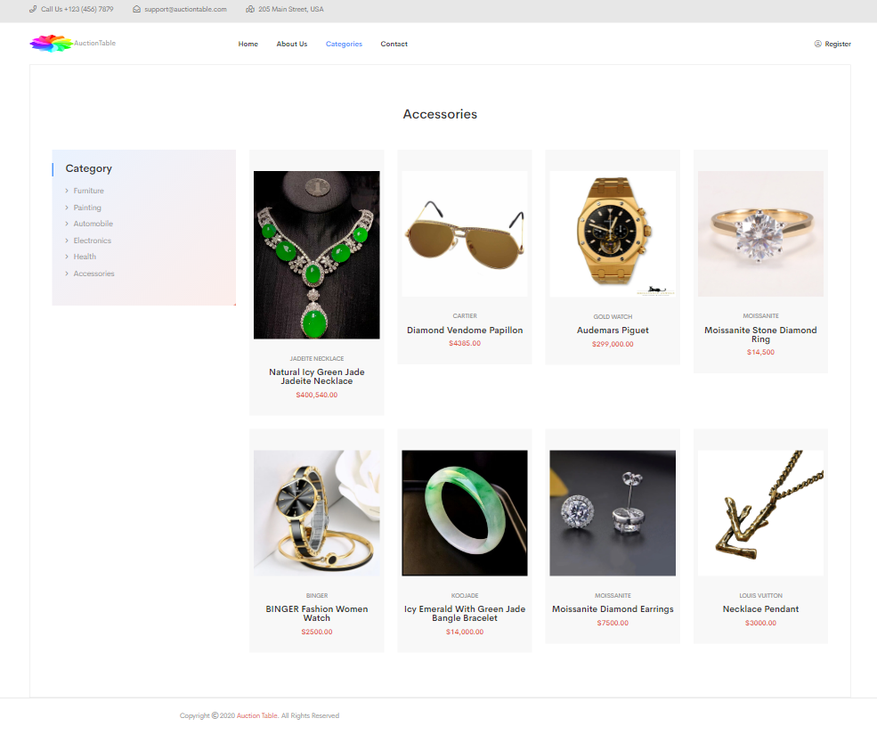

**SOURCE CODE**

**<!-- ACCESSORIS-area-start -->**

**<div class="features-products-area fe-product pl-55 pr-55">**

**<div class="container-fluid">**

**<div class="fe-pro-border">**

**<div class="row">**

**<div class="col-xl-6 col-lg-6 offset-lg-3 offset-xl-3">**

**<div class="section-title text-center mb-65">**

**<h2>Accessories</h2>**

**</div>**

**</div>**

**</div>**

**<div class="row">**

**<div class="col-xl-3 col-lg-3 mb-30">**

**<div class="category-sidebar">**

**<h3 class="cat-title">Category</h3>**

**<div class="category-item">**

**<ul>**

**<li><a href="furniture.html">Furniture</a></li>**

**<li><a href="paintings.html">Painting</a></li>**

**<li><a href="automobile.html">Automobile</a></li>**

**<li><a href="electronics.html">Electronics</a></li>**

**<li><a href="health.html">Health</a></li>**

**<li><a href="accessories.html">Accessories</a></li>**

**</ul>**

**</div>**

**</div>**

**</div>**

**<div class="col-xl-9 col-lg-9">**

**<div class="row">**

**<div class="col-xl-3 cl-lg-3 col-md-6">**

**<div class="product-03-wrapper grey-2-bg pos-rel text-center mb-30">**

**<div class="product-02-img pos-rel">**

**<a href="emerald_necklace.html">**

**<img src="assets/img/accessories/emerald_jadeite_necklace1.jpg" alt="">**

**</a>**

**</div>**

**<div class="product-text">**

**<h5>Jadeite Necklace</h5>**

**<h4><a href="emerald_necklace.html">Natural Icy Green Jade Jadeite Necklace</a></h4>**

**<span>$400,540.00</span>**

**</div>**

**</div>**

**</div>**

**<div class="col-xl-3 cl-lg-3 col-md-6">**

**<div class="product-03-wrapper grey-2-bg pos-rel text-center mb-30">**

**<div class="product-02-img pos-rel">**

**<a href="sunglass.html">**

**<img src="assets/img/accessories/cartier_sunglass1.jpg" alt="">**

**</a>**

**</div>**

**<div class="product-text">**

**<h5>Cartier</h5>**

**<h4><a href="sunglass.html">Diamond Vendome Papillon</a></h4>**

**<span>$4385.00</span>**

**</div>**

**</div>**

**</div>**

**<div class="col-xl-3 cl-lg-3 col-md-6">**

**<div class="product-03-wrapper grey-2-bg pos-rel text-center mb-30">**

**<div class="product-02-img pos-rel">**

**<a href="product_details.html">**

**<img src="assets/img/accessories/gold_watch1.jpg" alt="">**

**</a>**

**</div>**

**<div class="product-text">**

**<h5>Gold Watch</h5>**

**<h4><a href="g_watch.html">Audemars Piguet</a></h4>**

**<span>$299,000.00</span>**

**</div>**

**</div>**

**</div>**

**<div class="col-xl-3 cl-lg-3 col-md-6">**

**<div class="product-03-wrapper grey-2-bg pos-rel text-center mb-30">**

**<div class="product-02-img pos-rel">**

**<a href="d_ring.html">**

**<img src="assets/img/accessories/ring1.jpg" alt="">**

**</a>**

**</div>**

**<div class="product-text">**

**<h5>Moissanite</h5>**

**<h4><a href="d_ring.html"> Moissanite Stone Diamond Ring</a></h4>**

**<span>$14,500</span>**

**</div>**

**</div>**

**</div>**

**<div class="col-xl-3 cl-lg-3 col-md-6">**

**<div class="product-03-wrapper grey-2-bg pos-rel text-center mb-30">**

**<div class="product-02-img pos-rel">**

**<a href="w_watch.html">**

**<img src="assets/img/accessories/w_watch1.jpg" alt="">**

**</a>**

**</div>**

**<div class="product-text">**

**<h5>BINGER</h5>**

**<h4><a href="w_watch.html">BINGER Fashion Women Watch</a></h4>**

**<span>$2500.00</span>**

**</div>**

**</div>**

**</div>**

**<div class="col-xl-3 cl-lg-3 col-md-6">**

**<div class="product-03-wrapper grey-2-bg pos-rel text-center mb-30">**

**<div class="product-02-img pos-rel">**

**<a href="jade_bracelet.html">**

**<img src="assets/img/accessories/green_jade_bracelet1.jpg" alt="">**

**</a>**

**</div>**

**<div class="product-text">**

**<h5>KOOJADE</h5>**

**<h4><a href="jade_bracelet.html">Icy Emerald With Green Jade Bangle Bracelet</a></h4>**

**<span>$14,000.00</span>**

**</div>**

**</div>**

**</div>**

**<div class="col-xl-3 cl-lg-3 col-md-6">**

**<div class="product-03-wrapper grey-2-bg pos-rel text-center mb-30">**

**<div class="product-02-img pos-rel">**

**<a href="earring.html">**

**<img src="assets/img/accessories/earring1.jpg" alt="">**

**</a>**

**</div>**

**<div class="product-text">**

**<h5>Moissanite</h5>**

**<h4><a href="earring.html">Moissanite Diamond Earrings</a></h4>**

**<span>$7500.00</span>**

**</div>**

**</div>**

**</div>**

**<div class="col-xl-3 cl-lg-3 col-md-6">**

**<div class="product-03-wrapper grey-2-bg pos-rel text-center mb-30">**

**<div class="product-02-img pos-rel">**

**<a href="louis.html">**

**<img src="assets/img/accessories/louis_vuiton.jpg" alt="">**

**</a>**

**</div>**

**<div class="product-text">**

**<h5>Louis Vuitton</h5>**

**<h4><a href="louis.html">Necklace Pendant</a></h4>**

**<span>$3000.00</span>**

**</div>**

**</div>**

**</div>**

**</div>**

**</div>**

**</div>**

**</div>**

**</div>**

**</div>**

**<!-- features-products-area-end -->**

**<!-- footer-area-start -->**

**<footer>**

**<div class="footer-bottom-area pt-25 pb-25">**

**<div class="container">**

**<div class="row">**

**<div class="col-xl-6 col-lg-6 col-md-6">**

**<div class="copyright">**

**<p>Copyright <i class="far fa-copyright"></i> 2020 <a href="#">Auction Table</a>. All Rights Reserved</p>**

**</div>**

**</div>**

**</div>**

**</div>**

**</div>**

**</footer>**

**<!-- footer-area-end -->**

**<!-- JS here -->**

**<script src="assets/js/vendor/modernizr-3.5.0.min.js"></script>**

**<script src="assets/js/vendor/jquery-1.12.4.min.js"></script>**

**<script src="assets/js/popper.min.js"></script>**

**<script src="assets/js/bootstrap.min.js"></script>**

**<script src="assets/js/owl.carousel.min.js"></script>**

**<script src="assets/js/isotope.pkgd.min.js"></script>**

**<script src="assets/js/slick.min.js"></script>**

**<script src="assets/js/jquery.meanmenu.min.js"></script>**

**<script src="assets/js/ajax-form.js"></script>**

**<script src="assets/js/wow.min.js"></script>**

**<script src="assets/js/waypoints.min.js"></script>**

**<script src="assets/js/jquery.appear.js"></script>**

**<script src="assets/js/jquery.countdown.min.js"></script>**

**<script src="assets/js/jquery.knob.js"></script>**

**<script src="assets/js/jquery.counterup.min.js"></script>**

**<script src="assets/js/jquery.scrollUp.min.js"></script>**

**<script src="assets/js/imagesloaded.pkgd.min.js"></script>**

**<script src="assets/js/jquery.magnific-popup.min.js"></script>**

**<script src="assets/js/plugins.js"></script>**

**<script src="assets/js/main.js"></script>**

**CONTACT**

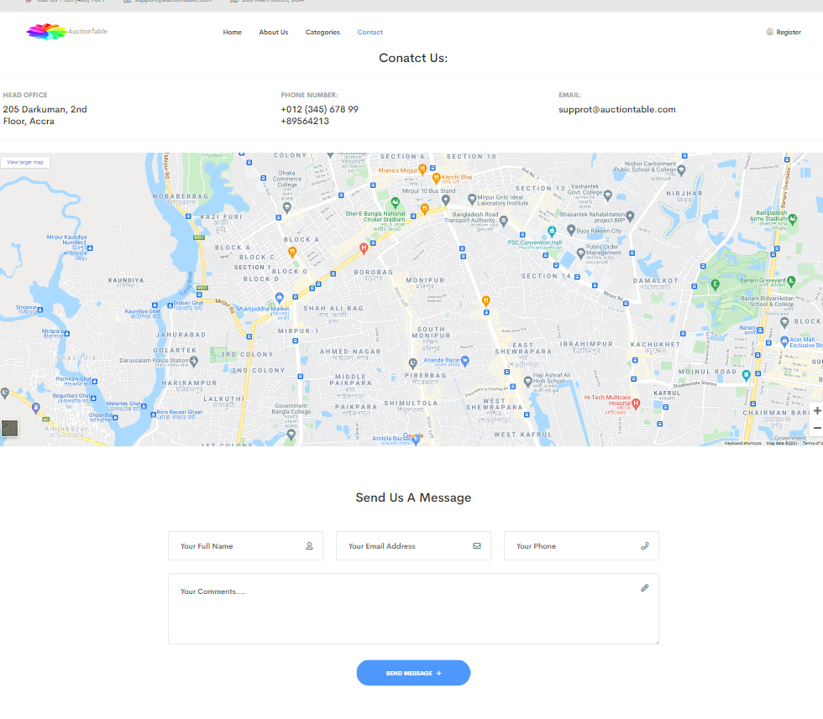

**SOURCE CODE**

   <!-- contact-area-start -->

            <div class="contact-area pt-100 pb-100">

                <div class="container">

                    <div class="row">

                        <div class="col-xl-6 col-lg-6 offset-lg-3 offset-xl-3">

                            <div class="section-title text-center mb-65">

                                <h2>Send Us A Message</h2>

                            </div>

                        </div>

                    </div>

                    <div class="row">

                        <div class="col-xl-12">

                            <form id="contacts-form" class="contacts-form" action="#">

                                <div class="row">

                                    <div class="col-lg-4 col-md-12">

                                        <div class="contacts-icon contactss-name">

                                            <input type="text" placeholder="Your Full Name " name="name">

                                        </div>

                                    </div>

                                    <div class="col-lg-4 col-md-12">

                                        <div class="contacts-icon contactss-email">

                                            <input type="email" placeholder="Your Email Address" name="email">

                                        </div>

                                    </div>

                                    <div class="col-lg-4 col-md-12">

                                        <div class="contacts-icon contactss-website">

                                            <input type="text" placeholder="Your Phone" name="number">

                                        </div>

                                    </div>

                                    <div class="col-lg-12">

                                        <div class="contacts-icon contactss-message" >

                                            <textarea name="comments" id="comments" cols="30" rows="10" placeholder="Your Comments...."></textarea>

                                        </div>

                                    </div>

                                    <div class="col-lg-12">

                                        <div class="contacts-form-button text-center">

                                            <button class="c-btn">

                                                send message <i class="far fa-plus"></i>

                                            </button>

                                        </div>

                                    </div>

                                </div>

                            </form>

                        </div>

                    </div>

                </div>

            </div>

            <!-- contact-area-end -->

         <!-- footer-area-start -->

        <footer>

        <div class="footer-bottom-area pt-25 pb-25">

            <div class="container">

                <div class="row">

                    <div class="col-xl-6 col-lg-6 col-md-6">

                        <div class="copyright">

                            <p>Copyright <i class="far fa-copyright"></i> 2020 <a href="#">Auction Table</a>. All Rights Reserved</p>

                        </div>

                    </div>

                </div>

            </div>

        </div>

        </footer>

        <!-- footer-area-end -->

                <!-- JS here -->

        <script src="assets/js/vendor/modernizr-3.5.0.min.js"></script>

        <script src="assets/js/vendor/jquery-1.12.4.min.js"></script>

        <script src="assets/js/popper.min.js"></script>

        <script src="assets/js/bootstrap.min.js"></script>

        <script src="assets/js/owl.carousel.min.js"></script>

        <script src="assets/js/isotope.pkgd.min.js"></script>

        <script src="assets/js/slick.min.js"></script>

        <script src="assets/js/jquery.meanmenu.min.js"></script>

        <script src="assets/js/ajax-form.js"></script>

        <script src="assets/js/wow.min.js"></script>

        <script src="assets/js/waypoints.min.js"></script>

        <script src="assets/js/jquery.appear.js"></script>

        <script src="assets/js/jquery.countdown.min.js"></script>

        <script src="assets/js/jquery.knob.js"></script>

        <script src="assets/js/jquery.counterup.min.js"></script>

        <script src="assets/js/jquery.scrollUp.min.js"></script>

        <script src="assets/js/imagesloaded.pkgd.min.js"></script>

        <script src="assets/js/jquery.magnific-popup.min.js"></script>

        <script src="assets/js/plugins.js"></script>

        <script src="assets/js/main.js"></script>

**REGISTER PAGE**

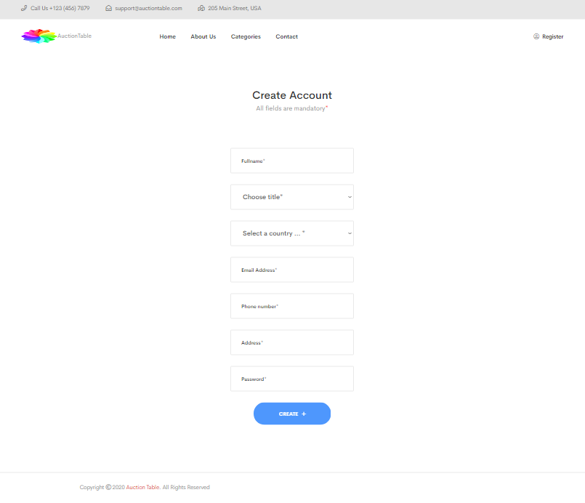

**SOURCE CODE**

<!-- contact-area-start -->

            <div class="contact-area pt-100 pb-100">

                <div class="container">

                    <div class="row">

                        <div class="col-xl-6 col-lg-6 offset-lg-3 offset-xl-3">

                            <div class="section-title text-center mb-65">

                                <h2>Create Account</h2>

                                <p>All fields are mandatory<span style="color: red;">*</span></p>

                            </div>

                        </div>

                    </div>

                    <div class="row">

                        <div class="form-body contacts-form">

                            <form action="index.html" name="myForm" onsubmit="return(validate());" method="GET">

                                <div>

                                    <input type="text" placeholder="Fullname*" name="Name" id="name">

                                </div>

                                <div>

                                    <select name="title" id="title">

                                        <option value="0" label="Choose title*" selected="Choose title" ></option>

                                        <optgroup label="Male">

                                            <option value="male">Mr.</option>

                                        </optgroup>

                                        <optgroup label="Female">

                                            <option value="female">Miss</option>

                                            <option value="female">Mrs</option>

                                        </optgroup>

                                    </select>

                                </div>

                                <div>

                                    <select name="Country" id="country">

                                        <option value="0" label="Select a country … *" selected="selected">Select a country …       </option>

                                        <optgroup id="country-optgroup-Africa" label="Africa">

                                        <option value="DZ" label="Algeria">Algeria</option>

                                        <option value="AO" label="Angola">Angola</option>

                                        <option value="BJ" label="Benin">Benin</option>

                                        <option value="BW" label="Botswana">Botswana</option>

                                        <option value="BF" label="Burkina Faso">Burkina Faso</option>

                                        <option value="BI" label="Burundi">Burundi</option>

                                        <option value="CM" label="Cameroon">Cameroon</option>

                                        <option value="CV" label="Cape Verde">Cape Verde</option>

                                        <option value="CF" label="Central African Republic">Central African Republic</option>

                                        <option value="TD" label="Chad">Chad</option>

                                        <option value="KM" label="Comoros">Comoros</option>

                                        <option value="CG" label="Congo - Brazzaville">Congo - Brazzaville</option>

                                        <option value="CD" label="Congo - Kinshasa">Congo - Kinshasa</option>

                                        <option value="CI" label="Côte d’Ivoire">Côte d’Ivoire</option>

                                        <option value="DJ" label="Djibouti">Djibouti</option>

                                        <option value="EG" label="Egypt">Egypt</option>

                                        <option value="GQ" label="Equatorial Guinea">Equatorial Guinea</option>

                                        <option value="ER" label="Eritrea">Eritrea</option>

                                        <option value="ET" label="Ethiopia">Ethiopia</option>

                                        <option value="GA" label="Gabon">Gabon</option>

                                        <option value="GM" label="Gambia">Gambia</option>

                                        <option value="GH" label="Ghana">Ghana</option>

                                        <option value="GN" label="Guinea">Guinea</option>

                                        <option value="GW" label="Guinea-Bissau">Guinea-Bissau</option>

                                        <option value="KE" label="Kenya">Kenya</option>

                                        <option value="LS" label="Lesotho">Lesotho</option>

                                        <option value="LR" label="Liberia">Liberia</option>

                                        <option value="LY" label="Libya">Libya</option>

                                        <option value="MG" label="Madagascar">Madagascar</option>

                                        <option value="MW" label="Malawi">Malawi</option>

                                        <option value="ML" label="Mali">Mali</option>

                                        <option value="MR" label="Mauritania">Mauritania</option>

                                        <option value="MU" label="Mauritius">Mauritius</option>

                                        <option value="YT" label="Mayotte">Mayotte</option>

                                        <option value="MA" label="Morocco">Morocco</option>

                                        <option value="MZ" label="Mozambique">Mozambique</option>

                                        <option value="NA" label="Namibia">Namibia</option>

                                        <option value="NE" label="Niger">Niger</option>

                                        <option value="NG" label="Nigeria">Nigeria</option>

                                        <option value="RW" label="Rwanda">Rwanda</option>

                                        <option value="RE" label="Réunion">Réunion</option>

                                        <option value="SH" label="Saint Helena">Saint Helena</option>

                                        <option value="SN" label="Senegal">Senegal</option>

                                        <option value="SC" label="Seychelles">Seychelles</option>

                                        <option value="SL" label="Sierra Leone">Sierra Leone</option>

                                        <option value="SO" label="Somalia">Somalia</option>

                                        <option value="ZA" label="South Africa">South Africa</option>

                                        <option value="SD" label="Sudan">Sudan</option>

                                        <option value="SZ" label="Swaziland">Swaziland</option>

                                        <option value="ST" label="São Tomé and Príncipe">São Tomé and Príncipe</option>

                                        <option value="TZ" label="Tanzania">Tanzania</option>

                                        <option value="TG" label="Togo">Togo</option>

                                        <option value="TN" label="Tunisia">Tunisia</option>

                                        <option value="UG" label="Uganda">Uganda</option>

                                        <option value="EH" label="Western Sahara">Western Sahara</option>

                                        <option value="ZM" label="Zambia">Zambia</option>

                                        <option value="ZW" label="Zimbabwe">Zimbabwe</option>

                                        </optgroup>

                                        <optgroup id="country-optgroup-Americas" label="Americas">

                                        <option value="AI" label="Anguilla">Anguilla</option>

                                        <option value="AG" label="Antigua and Barbuda">Antigua and Barbuda</option>

                                        <option value="AR" label="Argentina">Argentina</option>

                                        <option value="AW" label="Aruba">Aruba</option>

                                        <option value="BS" label="Bahamas">Bahamas</option>

                                        <option value="BB" label="Barbados">Barbados</option>

                                        <option value="BZ" label="Belize">Belize</option>

                                        <option value="BM" label="Bermuda">Bermuda</option>

                                        <option value="BO" label="Bolivia">Bolivia</option>

                                        <option value="BR" label="Brazil">Brazil</option>

                                        <option value="VG" label="British Virgin Islands">British Virgin Islands</option>

                                        <option value="CA" label="Canada">Canada</option>

                                        <option value="KY" label="Cayman Islands">Cayman Islands</option>

                                        <option value="CL" label="Chile">Chile</option>

                                        <option value="CO" label="Colombia">Colombia</option>

                                        <option value="CR" label="Costa Rica">Costa Rica</option>

                                        <option value="CU" label="Cuba">Cuba</option>

                                        <option value="DM" label="Dominica">Dominica</option>

                                        <option value="DO" label="Dominican Republic">Dominican Republic</option>

                                        <option value="EC" label="Ecuador">Ecuador</option>

                                        <option value="SV" label="El Salvador">El Salvador</option>

                                        <option value="FK" label="Falkland Islands">Falkland Islands</option>

                                        <option value="GF" label="French Guiana">French Guiana</option>

                                        <option value="GL" label="Greenland">Greenland</option>

                                        <option value="GD" label="Grenada">Grenada</option>

                                        <option value="GP" label="Guadeloupe">Guadeloupe</option>

                                        <option value="GT" label="Guatemala">Guatemala</option>

                                        <option value="GY" label="Guyana">Guyana</option>

                                        <option value="HT" label="Haiti">Haiti</option>

                                        <option value="HN" label="Honduras">Honduras</option>

                                        <option value="JM" label="Jamaica">Jamaica</option>

                                        <option value="MQ" label="Martinique">Martinique</option>

                                        <option value="MX" label="Mexico">Mexico</option>

                                        <option value="MS" label="Montserrat">Montserrat</option>

                                        <option value="AN" label="Netherlands Antilles">Netherlands Antilles</option>

                                        <option value="NI" label="Nicaragua">Nicaragua</option>

                                        <option value="PA" label="Panama">Panama</option>

                                        <option value="PY" label="Paraguay">Paraguay</option>

                                        <option value="PE" label="Peru">Peru</option>

                                        <option value="PR" label="Puerto Rico">Puerto Rico</option>

                                        <option value="BL" label="Saint Barthélemy">Saint Barthélemy</option>

                                        <option value="KN" label="Saint Kitts and Nevis">Saint Kitts and Nevis</option>

                                        <option value="LC" label="Saint Lucia">Saint Lucia</option>

                                        <option value="MF" label="Saint Martin">Saint Martin</option>

                                        <option value="PM" label="Saint Pierre and Miquelon">Saint Pierre and Miquelon</option>

                                        <option value="VC" label="Saint Vincent and the Grenadines">Saint Vincent and the Grenadines</option>

                                        <option value="SR" label="Suriname">Suriname</option>

                                        <option value="TT" label="Trinidad and Tobago">Trinidad and Tobago</option>

                                        <option value="TC" label="Turks and Caicos Islands">Turks and Caicos Islands</option>

                                        <option value="VI" label="U.S. Virgin Islands">U.S. Virgin Islands</option>

                                        <option value="US" label="United States">United States</option>

                                        <option value="UY" label="Uruguay">Uruguay</option>

                                        <option value="VE" label="Venezuela">Venezuela</option>

                                        </optgroup>

                                        <optgroup id="country-optgroup-Asia" label="Asia">

                                        <option value="AF" label="Afghanistan">Afghanistan</option>

                                        <option value="AM" label="Armenia">Armenia</option>

                                        <option value="AZ" label="Azerbaijan">Azerbaijan</option>

                                        <option value="BH" label="Bahrain">Bahrain</option>

                                        <option value="BD" label="Bangladesh">Bangladesh</option>

                                        <option value="BT" label="Bhutan">Bhutan</option>

                                        <option value="BN" label="Brunei">Brunei</option>

                                        <option value="KH" label="Cambodia">Cambodia</option>

                                        <option value="CN" label="China">China</option>

                                        <option value="CY" label="Cyprus">Cyprus</option>

                                        <option value="GE" label="Georgia">Georgia</option>

                                        <option value="HK" label="Hong Kong SAR China">Hong Kong SAR China</option>

                                        <option value="IN" label="India">India</option>

                                        <option value="ID" label="Indonesia">Indonesia</option>

                                        <option value="IR" label="Iran">Iran</option>

                                        <option value="IQ" label="Iraq">Iraq</option>

                                        <option value="IL" label="Israel">Israel</option>

                                        <option value="JP" label="Japan">Japan</option>

                                        <option value="JO" label="Jordan">Jordan</option>

                                        <option value="KZ" label="Kazakhstan">Kazakhstan</option>

                                        <option value="KW" label="Kuwait">Kuwait</option>

                                        <option value="KG" label="Kyrgyzstan">Kyrgyzstan</option>

                                        <option value="LA" label="Laos">Laos</option>

                                        <option value="LB" label="Lebanon">Lebanon</option>

                                        <option value="MO" label="Macau SAR China">Macau SAR China</option>

                                        <option value="MY" label="Malaysia">Malaysia</option>

                                        <option value="MV" label="Maldives">Maldives</option>

                                        <option value="MN" label="Mongolia">Mongolia</option>

                                        <option value="MM" label="Myanmar [Burma]">Myanmar [Burma]</option>

                                        <option value="NP" label="Nepal">Nepal</option>

                                        <option value="NT" label="Neutral Zone">Neutral Zone</option>

                                        <option value="KP" label="North Korea">North Korea</option>

                                        <option value="OM" label="Oman">Oman</option>

                                        <option value="PK" label="Pakistan">Pakistan</option>

                                        <option value="PS" label="Palestinian Territories">Palestinian Territories</option>

                                        <option value="YD" label="People's Democratic Republic of Yemen">People's Democratic Republic of Yemen</option>

                                        <option value="PH" label="Philippines">Philippines</option>

                                        <option value="QA" label="Qatar">Qatar</option>

                                        <option value="SA" label="Saudi Arabia">Saudi Arabia</option>

                                        <option value="SG" label="Singapore">Singapore</option>

                                        <option value="KR" label="South Korea">South Korea</option>

                                        <option value="LK" label="Sri Lanka">Sri Lanka</option>

                                        <option value="SY" label="Syria">Syria</option>

                                        <option value="TW" label="Taiwan">Taiwan</option>

                                        <option value="TJ" label="Tajikistan">Tajikistan</option>

                                        <option value="TH" label="Thailand">Thailand</option>

                                        <option value="TL" label="Timor-Leste">Timor-Leste</option>

                                        <option value="TR" label="Turkey">Turkey</option>

                                        <option value="™" label="Turkmenistan">Turkmenistan</option>

                                        <option value="AE" label="United Arab Emirates">United Arab Emirates</option>

                                        <option value="UZ" label="Uzbekistan">Uzbekistan</option>

                                        <option value="VN" label="Vietnam">Vietnam</option>

                                        <option value="YE" label="Yemen">Yemen</option>

                                        </optgroup>

                                        <optgroup id="country-optgroup-Europe" label="Europe">

                                        <option value="AL" label="Albania">Albania</option>

                                        <option value="AD" label="Andorra">Andorra</option>

                                        <option value="AT" label="Austria">Austria</option>

                                        <option value="BY" label="Belarus">Belarus</option>

                                        <option value="BE" label="Belgium">Belgium</option>

                                        <option value="BA" label="Bosnia and Herzegovina">Bosnia and Herzegovina</option>

                                        <option value="BG" label="Bulgaria">Bulgaria</option>

                                        <option value="HR" label="Croatia">Croatia</option>

                                        <option value="CY" label="Cyprus">Cyprus</option>

                                        <option value="CZ" label="Czech Republic">Czech Republic</option>

                                        <option value="DK" label="Denmark">Denmark</option>

                                        <option value="DD" label="East Germany">East Germany</option>

                                        <option value="EE" label="Estonia">Estonia</option>

                                        <option value="FO" label="Faroe Islands">Faroe Islands</option>

                                        <option value="FI" label="Finland">Finland</option>

                                        <option value="FR" label="France">France</option>

                                        <option value="DE" label="Germany">Germany</option>

                                        <option value="GI" label="Gibraltar">Gibraltar</option>

                                        <option value="GR" label="Greece">Greece</option>

                                        <option value="GG" label="Guernsey">Guernsey</option>

                                        <option value="HU" label="Hungary">Hungary</option>

                                        <option value="IS" label="Iceland">Iceland</option>

                                        <option value="IE" label="Ireland">Ireland</option>

                                        <option value="IM" label="Isle of Man">Isle of Man</option>

                                        <option value="IT" label="Italy">Italy</option>

                                        <option value="JE" label="Jersey">Jersey</option>

                                        <option value="LV" label="Latvia">Latvia</option>

                                        <option value="LI" label="Liechtenstein">Liechtenstein</option>

                                        <option value="LT" label="Lithuania">Lithuania</option>

                                        <option value="LU" label="Luxembourg">Luxembourg</option>

                                        <option value="MK" label="Macedonia">Macedonia</option>

                                        <option value="MT" label="Malta">Malta</option>

                                        <option value="FX" label="Metropolitan France">Metropolitan France</option>

                                        <option value="MD" label="Moldova">Moldova</option>

                                        <option value="MC" label="Monaco">Monaco</option>

                                        <option value="ME" label="Montenegro">Montenegro</option>

                                        <option value="NL" label="Netherlands">Netherlands</option>

                                        <option value="NO" label="Norway">Norway</option>

                                        <option value="PL" label="Poland">Poland</option>

                                        <option value="PT" label="Portugal">Portugal</option>

                                        <option value="RO" label="Romania">Romania</option>

                                        <option value="RU" label="Russia">Russia</option>

                                        <option value="SM" label="San Marino">San Marino</option>

                                        <option value="RS" label="Serbia">Serbia</option>

                                        <option value="CS" label="Serbia and Montenegro">Serbia and Montenegro</option>

                                        <option value="SK" label="Slovakia">Slovakia</option>

                                        <option value="SI" label="Slovenia">Slovenia</option>

                                        <option value="ES" label="Spain">Spain</option>

                                        <option value="SJ" label="Svalbard and Jan Mayen">Svalbard and Jan Mayen</option>

                                        <option value="SE" label="Sweden">Sweden</option>

                                        <option value="CH" label="Switzerland">Switzerland</option>

                                        <option value="UA" label="Ukraine">Ukraine</option>

                                        <option value="SU" label="Union of Soviet Socialist Republics">Union of Soviet Socialist Republics</option>

                                        <option value="GB" label="United Kingdom">United Kingdom</option>

                                        <option value="VA" label="Vatican City">Vatican City</option>

                                        <option value="AX" label="Åland Islands">Åland Islands</option>

                                        </optgroup>

                                        <optgroup id="country-optgroup-Oceania" label="Oceania">

                                        <option value="AS" label="American Samoa">American Samoa</option>

                                        <option value="AQ" label="Antarctica">Antarctica</option>

                                        <option value="AU" label="Australia">Australia</option>

                                        <option value="BV" label="Bouvet Island">Bouvet Island</option>

                                        <option value="IO" label="British Indian Ocean Territory">British Indian Ocean Territory</option>

                                        <option value="CX" label="Christmas Island">Christmas Island</option>

                                        <option value="CC" label="Cocos [Keeling] Islands">Cocos [Keeling] Islands</option>

                                        <option value="CK" label="Cook Islands">Cook Islands</option>

                                        <option value="FJ" label="Fiji">Fiji</option>

                                        <option value="PF" label="French Polynesia">French Polynesia</option>

                                        <option value="TF" label="French Southern Territories">French Southern Territories</option>

                                        <option value="GU" label="Guam">Guam</option>

                                        <option value="HM" label="Heard Island and McDonald Islands">Heard Island and McDonald Islands</option>

                                        <option value="KI" label="Kiribati">Kiribati</option>

                                        <option value="MH" label="Marshall Islands">Marshall Islands</option>

                                        <option value="FM" label="Micronesia">Micronesia</option>

                                        <option value="NR" label="Nauru">Nauru</option>

                                        <option value="NC" label="New Caledonia">New Caledonia</option>

                                        <option value="NZ" label="New Zealand">New Zealand</option>

                                        <option value="NU" label="Niue">Niue</option>

                                        <option value="NF" label="Norfolk Island">Norfolk Island</option>

                                        <option value="MP" label="Northern Mariana Islands">Northern Mariana Islands</option>

                                        <option value="PW" label="Palau">Palau</option>

                                        <option value="PG" label="Papua New Guinea">Papua New Guinea</option>

                                        <option value="PN" label="Pitcairn Islands">Pitcairn Islands</option>

                                        <option value="WS" label="Samoa">Samoa</option>

                                        <option value="SB" label="Solomon Islands">Solomon Islands</option>

                                        <option value="GS" label="South Georgia and the South Sandwich Islands">South Georgia and the South Sandwich Islands</option>

                                        <option value="TK" label="Tokelau">Tokelau</option>

                                        <option value="TO" label="Tonga">Tonga</option>

                                        <option value="TV" label="Tuvalu">Tuvalu</option>

                                        <option value="UM" label="U.S. Minor Outlying Islands">U.S. Minor Outlying Islands</option>

                                        <option value="VU" label="Vanuatu">Vanuatu</option>

                                        <option value="WF" label="Wallis and Futuna">Wallis and Futuna</option>

                                        </optgroup>

                                    </select>

                                </div>

                                <div>

                                    <input type="email" placeholder="Email Address*" name="email" id="email">

                                </div>

                                <div>

                                    <input type="text" placeholder="Phone number*" name="number" id="contact">

                                </div>

                                <div>

                                    <input type="Address" placeholder="Address*" name="address">

                                </div>

                                <div>

                                    <input type="text" placeholder="Password*" name="password">

                                </div>

                                <div class="col-lg-12">

                                    <div class="contacts-form-button text-center">

                                    <button class="c-btn" value="Submit" type="submit">

                                        create <i class="far fa-plus"></i>

                                    </button>

                                </div>

                                </div>

                            </form>

                        </div>

                    </div>

                </div>

            </div>

            <!-- contact-area-end -->

         <!-- footer-area-start -->

        <footer>

        <div class="footer-bottom-area pt-25 pb-25">

            <div class="container">

                <div class="row">

                    <div class="col-xl-6 col-lg-6 col-md-6">

                        <div class="copyright">

                            <p>Copyright <i class="far fa-copyright"></i> 2020 <a href="#">Auction Table</a>. All Rights Reserved</p>

                        </div>

                    </div>

                </div>

            </div>

        </div>

        </footer>

        <!-- footer-area-end -->

        <script>

        </script>

                <!-- JS here -->

        <script src="assets/js/vendor/modernizr-3.5.0.min.js"></script>

        <script src="assets/js/vendor/jquery-1.12.4.min.js"></script>

        <script src="assets/js/popper.min.js"></script>

        <script src="assets/js/bootstrap.min.js"></script>

        <script src="assets/js/owl.carousel.min.js"></script>

        <script src="assets/js/isotope.pkgd.min.js"></script>

        <script src="assets/js/slick.min.js"></script>

        <script src="assets/js/jquery.meanmenu.min.js"></script>

        <script src="assets/js/ajax-form.js"></script>

        <script src="assets/js/wow.min.js"></script>

        <script src="assets/js/waypoints.min.js"></script>

        <script src="assets/js/jquery.appear.js"></script>

        <script src="assets/js/jquery.countdown.min.js"></script>

        <script src="assets/js/jquery.knob.js"></script>

        <script src="assets/js/jquery.counterup.min.js"></script>

        <script src="assets/js/jquery.scrollUp.min.js"></script>

        <script src="assets/js/imagesloaded.pkgd.min.js"></script>

        <script src="assets/js/jquery.magnific-popup.min.js"></script>

        <script src="assets/js/plugins.js"></script>

        <script src="assets/js/main.js"></script>

        <script src="assets/js/form_validator.js"></script>

        <script src="form_validator.js"></script>

|  |  |
| --- | --- |
|  | |
|  |  | |
|  |  | |
|  |  | |
|  |  | |
|  |  | |
|  |  | |
|  |  | |
|  |  | |
|  |  | |
|  |  | |
|  |  | |
|  |  | |
|  |  | |
|  |  | |
|  |  | |
|  |  | |
|  |  | |
|  |  | |
|  |  | |
|  |  | |
|  |  | |
|  |  | |
|  |  | |
|  |  | |
|  |  | |
|  |  | |
|  |  | |
|  |  | |
|  |  | |
|  |  | |
|  |  | |
|  |  | |
|  |  | |
|  |  | |
|  |  | |
|  |  | |
|  |  | |
|  |  | |
|  |  | |
|  |  | |
|  |  | |
|  |  | |
|  |  | |
|  |  | |
|  |  | |
|  |  | |
|  |  | |
|  |  | |
|  |  | |
|  |  | |
|  |  | |
|  |  | |
|  |  | |
|  |  | |
|  |  | |
|  |  | |
|  |  | |
|  |  | |
|  |  | |
|  |  | |
|  |  | |
|  |  | |
|  |  | |
|  |  | |
|  |  | |
|  |  | |
|  |  | |
|  |  | |
|  |  | |
|  |  | |
|  |  | |
|  |  | |
|  |  | |
|  |  | |
|  |  | |
|  |  | |
|  |  | |
|  |  | |
|  |  | |
|  |  | |
|  |  | |
|  |  | |
|  |  | |
|  |  | |
|  |  | |
|  |  | |
|  |  | |
|  |  | |
|  |  | |
|  |  | |
|  |  | |
|  |  | |
|  |  | |
|  |  | |
|  |  | |
|  |  | |
|  |  | |
|  |  | |
|  |  | |
|  |  | |
|  |  | |
|  |  | |
|  |  | |
|  |  | |
|  |  | |
|  |  | |
|  |  | |
|  |  | |
|  |  | |
|  |  | |
|  |  | |
|  |  | |
|  |  | |
|  |  | |
|  |  | |
|  |  | |
|  |  | |
|  |  | |
|  |  | |
|  |  | |
|  |  | |
|  |  | |
|  |  | |
|  |  | |
|  |  | |
|  |  | |
|  |  | |
|  |  | |
|  |  | |
|  |  | |
|  |  | |
|  |  | |
|  |  | |
|  |  | |
|  |  | |
|  |  | |
|  |  | |
|  |  | |
|  |  | |
|  |  | |
|  |  | |
|  |  | |
|  |  | |
|  |  | |
|  |  | |
|  |  | |
|  |  | |
|  |  | |
|  |  | |
|  |  | |
|  |  | |
|  |  | |
|  |  | |
|  |  | |
|  |  | |
|  |  | |
|  |  | |
|  |  | |
|  |  | |
|  |  | |
|  |  | |
|  |  | |
|  |  | |
|  |  | |
|  |  | |
|  |  | |
|  |  | |
|  |  | |
|  |  | |
|  |  | |
|  |  | |
|  |  | |
|  |  | |
|  |  | |
|  |  | |
|  |  | |
|  |  | |
|  |  | |
|  |  | |
|  |  | |
|  |  | |
|  |  | |
|  |  | |
|  |  | |
|  |  | |
|  |  | |
|  |  | |
|  |  | |
|  |  | |
|  |  | |
|  |  | |
|  |  | |
|  |  | |
|  |  | |
|  |  | |
|  |  | |
|  |  | |
|  |  | |
|  |  | |
|  |  | |
|  |  | |
|  |  | |

|  |  |
| --- | --- |
|  |  |
|  |  |
|  |  |
|  |  |
|  |  |
|  |  |